BIRMINGHAM LAW SOCIETY – TERMS OF REFERENCE FOR COUNCIL
………………………………………………………………………………………………………………….

INTRODUCTION
These Terms of Reference for Council provide for the structure and operation of Birmingham Law Society’s Council which is to be read in conjunction with the Articles of Association for the Birmingham Law Society.
- The President of the Birmingham Law Society at the date hereof is Tony McDaid.
- The Vice President of the Birmingham Law Society at the date hereof is Alice Kinder.
- The Deputy Vice President of the Birmingham Law Society at the date hereof is Richard Port MBE.
The Members of Council at the date hereof are the persons whose names appear in the Schedule 1 of Council Members attached hereto.
These Terms of Reference shall initially come into effect on the date on which the new Articles of Association for the Society are adopted and initialled on behalf of the Directors and Council by way of identification. With effect from such date, these Terms of Reference shall replace and supersede any previous Rules, Constitution or Terms of Reference for Council that may have been effective at the time.
In accordance with Term 72, some of the Terms contained below cannot be amended without the new Articles of Association for the Birmingham Law Society being amended under the relevant provisions of those Articles. All other Terms contained here can be amended as provided under Terms 73 and 74.
For ease, provisions that appear directly from the Articles have been italicised within the Terms of Reference.
Reference to “Articles” or “Article” relates to the Articles of Association for the Birmingham Law Society.
Reference to “Terms” or “Term” relates to these Terms of Reference for Council.
INTERPRETATION
In these Terms of Reference, unless otherwise expressly provided:
“Affiliate Members” means those defined under Term 57.
“Approved Regulator” means the SRA, BSB, CILEX Professional Standards Board and any other Approved Regulator under the Legal Services Act 2007.
“Ballot” means a system of voting in secret and shall include a ballot paper sent and returned by email or by some other electronic means in accordance with the ballot procedure attached at Schedule 2.
“Birmingham area” means the City of Birmingham and the surrounding area.
“Board” means the Directors of the Society as defined under Article 8.
“BSB” means the Bar Standards Board and any successor body from time to time.
“CILEX” means the Chartered Institute of Legal Executives and any successor body from time to time.
“Council members” means the persons elected, co-opted, appointed or otherwise to Council under Terms 2 and 3.
“Full Members” means those defined under Term 56.
“Honorary Members” means those defined under Term 59.
“Lawyer” means any of the persons defined in Term 57.
“membership” means those persons or organisations who have, either through individual or corporate membership, paid subscriptions to become members of the Society.
“Officers of the Society” means the President, the Vice President, the Deputy Vice President and the Honorary Secretaries.
“Professional Committees” means a committee established by Council under Term 63 to consider such professional issues relevant to their remit.
“SRA” means the Solicitors Regulation Authority and any successor body from time to time.
“the Society” means the Birmingham Law Society who is a private company limited by guarantee, registered in England and Wales under registration number 00005188 and who’s registered address is Suite 101, Cheltenham House, 14-16 Temple Street, Birmingham, B2 5BG.
“TLS” means The Law Society of England and Wales and any successor body from time to time.
OBJECTS
- The objects for which Council is established are defined under Article 2 are:

  - To support and protect the character, status, and interest of the legal profession generally, and particularly of members practicing law in the Birmingham area;

  - To promote honourable practice, to repress malpractice, to settle disputed points of practice, and to decide all questions of professional usage or courtesy between or among legal professionals, and particularly as between members of the Society;

  - To consider all questions affecting the interests of the profession, and to respond to consultations, and, if thought necessary or advisable to petition Parliament, the SRA, BSB, TLS or other body or promote deputations in relations to general measurers directly or indirectly affecting the profession, and to procure changes of law or practice, and to promote improvements in the principles and administrations of the law;

  - To arrange and promote social events for the benefit of members and their guests, and generally to promote the interests of the Society;

  - To encourage the study of law and for that purpose to provide on such terms and conditions as may from time to time be prescribed, a prize or prizes, or other rewards or distinctions; and

  - To promote information on legal subjects by lectures, discussions, books, correspondence with public bodies and individuals or otherwise;
STRUCTURE OF COUNCIL
- The Council of the Society shall consist of the following who shall have voting rights:

  - The Officers of the Society as defined in Article 19 and Term 14 below;

  - The immediate past-President for a term of one year after the end of their Presidential year;

  - Up to 8 Full Members of the Society elected to Council under Terms 34- 39. They cease to be a member of Council under Terms 46 and 47.

  - Up to 4 additional persons co-opted by the sitting President for the duration of the President’s term in office so long as they are from the membership of the Society; and

  - Honorary Members as defined by Term 59;

- In addition to those persons identified in Term 2 of these Terms of Reference for Council, The Council of the Society shall also consist of the following who will not have voting rights:

  - Any member of the Society’s staff who can attend meetings of Council by invitation from the President;

  - Any number of Board members from time to time to attend meetings of Council by invitation from the President;

  - Representatives of approved local legal associations for lawyers such as:
    - The Birmingham Young Solicitors Group;
    - The Birmingham Trainee Solicitors Group;
    - The Birmingham Solicitors Group;
    - The Birmingham Black Lawyers Society
    - The Sole Practitioner’s Group.
who’s appointment onto Council shall be pursuant to Term 44;
  - The representatives from The Law Society and Birmingham and District TLS Council Members; and

  - Any additional person co-opted, which for the avoidance of doubt could include either Full Members, Affiliate Members or non-members, by the President for a specific purpose, such as to advise or assist the President with their initiatives or the Objects of the Council under Term 1 of these Terms of Reference for Council.
COUNCIL MEETINGS
- There shall be a meeting of Council monthly or such other frequency as Council determines from time to time either in person, virtually or hybrid.

- Only those persons appointed or elected to Council under Term 2 of these Terms of Reference for Council shall be entitled to one vote on each item of business.

- The quorum for a Council meeting shall be five members who are entitled to vote under Term 2 but one of whom must be either the President, the Vice-President or the Deputy Vice-President of the Society.

- The date, time and place (including whether virtual or hybrid), together with an agenda shall be endeavoured to be served in writing on all Council members at least 24 hours before the Council meeting.

- The agenda shall include, inter alia, such proposals for business as decided by the President but usually will include the following standing items:

  - Apologies for absence;
  - Approval of the minutes of the last Council meeting;
  - Matters arising from the minutes of the last meeting;
  - To receive a President’s and Officers’ update;
  - To receive a Report from The Law Society and Birmingham and District TLS Council Members;
  - To receive the Confidential Regulatory Report;
  - To approve or reject Membership Applications; and
  - To take as read updates from the Professional Committees of the Society and to receive an update from a Professional Committee’s Chair if required.

- The President, or in their absence the Vice President, or in their absence the Deputy Vice President, shall preside as Chair at every Council meeting.

- Subject to the provisions of these Terms of Reference for Council, Council meetings shall be conducted in whatever manner the Chair deems most convenient. In particular, the Chair may determine that debate on a particular matter has been exhausted and that such matter should be put to a vote or moved on with.

- Save for when a ballot is required, questions or business arising at a Council meeting shall be decided by a simple majority vote of eligible voters and the Chair shall have a second or casting vote.

- Minutes of a Council meeting will be taken by the Honorary Secretaries for the Society, kept centrally with the Society’s office and be made available upon request to all the membership.

- In addition to the usual monthly Council meeting, the President shall have the authority and freedom to set up sub-committees or groups to assist them with specific topics without the need for Council’s approval. Members of such sub-committee or group shall be such persons as the President determines from time to time and the frequency upon which such sub-committee or group shall meet shall be as often as the President determines.
THE OFFICERS OF THE SOCIETY
General provisions relating to the Officers of the Society
- In accordance with Article 19, and in the definition of these Terms of Reference, the Officers for the Society are the President, the Vice-President, the Deputy Vice President and the Honorary Secretaries.

- The term of office for each Officer shall be one year from the date of their appointment at the Society’s AGM.

- An Officer of the Society may be removed from their role before the expiry of their term of office only by special resolution at a Council meeting. When deciding whether to remove an Officer of the Society from their role, Council will have regard to the circumstances, any conflicts of interest or if the behaviour of the Officer is, in their absolute opinion, unbecoming of somebody holding such office. The Officer so removed will remain a Member of the Society subject to Term 17 and Article 19.4 and the termination provisions set out in the Articles at 23 and Term 61.

- For the avoidance of doubt, an Officer of the Society shall also be deemed to be removed from Office on their ceasing to be a member of the Society for any reason, or on their resignation as an Officer of the Society taking effect.
Appointment of Officers of the Society
- At the last meeting of Council before the Annual General Meeting, the Council shall elect from the membership the Officers of the Society.

- There is no eligibility criteria for a candidate who wishes to be an Officer of the Society except for that they must be a Full Member of the Society.

- In the event of more than one nomination for any office, the election shall be by secret ballot in accordance with the ballot procedure attached at Schedule 2. The ballot shall be decided by simple majority of those members of Council in attendance at the meeting providing it is quorate pursuant to Term 6.

- On a ballot involving more than two candidates where no candidate obtains more than half of the votes capable of being cast at the meeting, the candidate with the fewest number of votes shall withdraw. In the event of more than one candidate having equal numbers of the fewest votes cast, the candidate to withdraw shall be decided by lot. A further ballot of the remaining candidates shall be held and any further ballots as necessary until an Officer is duly elected by the requisite simple majority of votes capable of being cast at the Council meeting.

- The Officers, when so appointed, shall take up their offices at the conclusion of the Annual General Meeting of the Society and (subject to the provisions of these Terms or the relevant provisions within the Articles) shall hold their office until conclusion of the Annual General Meeting the following year.

- Such Officers, if not already a member of Council, will become ex-officio members of Council and accordingly shall not be subject to election; or where such Officer is already a member of Council then (a) if their term on Council continues beyond holding office then they shall continue to be a member of Council upon ceasing to be an Officer (b) if their term on Council ends whilst holding office they shall be re-elected to Council whilst holding office.
The President
- The role of the President is to:

  - Champion and lead the Society’s aims and objectives;

  - Represent the Society to all external agencies/bodies;

  - Be an ambassador and leader for the legal profession and the Society; and

  - Lead Council.

- The President’s key tasks are to:

  - Communicate with the legal profession and with members of Council;

  - Be the Society’s spokesperson;

  - Represent the Society on ceremonial occasions;

  - Build effective relationships with influential external bodies;

  - Meet with sponsors and forge links with potential sponsors;

  - Chair Council meetings;

  - Chair monthly Officers’ meetings;

  - Attend at least one of the Professional Committees’ meetings during their term;

  - Build effective working relationships between the officeholders, Council members and Chairs of the Society’s Professional Committees;

  - Attend Board meetings as an ex-offico member of the Board during their term in office;

  - Represent the Society in the media and on social media platforms;

  - Chair the Managing Partner/Senior Leader meetings; and

  - Develop relationships with the Society’s membership.
The Vice-President
- The role of the Vice-President is to:

  - Assist the President in all their role under Term 24 above, and to deputise for them when necessary; and

  - Undertake such other responsibilities and duties as may be delegated to them by Council or the President.

- The Vice-President’s key tasks are to:

  - Chair their think tank group in preparation for them becoming President;

  - Build effective working relationships with Council members and the Board;

  - Meet with sponsors and forge links with potential sponsors;

  - Attend Council meetings;

  - Attend monthly Officers’ meetings;

  - Attend Board meetings as an ex-officio member of the Board during their term in office;

  - Attend at least one of the Professional Committee’s meetings during their term;

  - Develop relationships with the Society’s membership.
The Deputy Vice-President
- The role of the Deputy Vice-President is to:

  - Assist the President and Vice-President in all their functions and to deputise for them when necessary; and

  - Undertake such other responsibilities or duties as may be delegated by Council or the President.

- The Deputy Vice-President’s key tasks are to:

  - Build effective working relationships with Council members and the Board;

  - Meet with sponsors and forge links with potential sponsors;

  - Attend Council meetings;

  - Attend monthly Officers’ meetings;

  - Attend Board meetings as an ex-officio member of the Board during their term in office;

  - Attend at least one of the Professional Committee’s meetings during their term;

  - Develop relationships with the Society’s membership.

  - Be the conduit between the Professional Committees and Council.
Honorary Secretaries
- The role of the Honorary Secretaries is to:

  - Be responsible for ensuring support for the President and Council;

  - Undertake and assist the office of the Society in making arrangements for the Society’s Annual General Meeting, and Extraordinary General Meetings and Council meetings;

  - Assist the President, Vice-President and Deputy Vice-President at the meetings of the Officers and Council.

- The Honorary Secretaries’ key tasks are to:

  - Provide secretarial support for Council meetings, ensuring the agenda and minutes are produced on time;

  - Provide support for the Annual General Meeting for the Society and any Extraordinary General Meetings;

  - Provide secretarial and administrative support for the Officers’ meetings;

  - Liaise with the Society’s staff, where appropriate;

  - Actively contribute in Council and Officers’ meetings to assist with the aims and objectives of the Society;

  - Attend other associated meetings, where possible, for example, Joint V meetings;

  - Actively be involved in the Society’s initiatives;

  - Plan the annual cycle of Council and Officers’ meetings with the President, Vice-President and Deputy Vice-President;

  - Work co-operatively with the other Honorary Secretary, to share the workload, and to ensure that cover is provided for these tasks and duties where necessary; and

  - Provide any written reports as requested by the President.
THE COUNCIL
Functions of Council
- Article 18 of the Articles of Association for the Society establishes Council who shall be responsible for ensuring the Society meets the aims and objectives pursuant to the Objects in Article 2 and Term 1.

- Council shall have the following functions:

  - The appointment and termination of membership to the Society for those eligible under Term 49 to 61. For the avoidance of doubt, the Board approve member subscription fees or levies in accordance with Article 3.1.5 and Article 26.

  - The establishment of Professional Committees and approval of their Terms of Reference;

  - The appointment of and, where necessary, the removal of Professional Committee Chairs;

  - The appointment of and, where necessary, the removal of the President, the Vice-President, the Deputy Vice President or one or both of the Honorary Secretaries in accordance with the relevant provisions of these Terms or such other policy as in effect from time to time;
Appointment of Full Members of Council
- At the Annual General Meeting for the Society, where there are vacancies created as a consequence of Term 45, the membership shall elect up to six Full Members to become Council members.

- A candidate who has indicated to an existing Officer of the Society their willingness to be nominated to become a Council member shall be deemed to have been proposed and seconded by members of Council.

- In the event of more nominations being received than vacancies on offer, the election shall be by secret ballot in accordance with the ballot procedure. The ballot shall be decided by simple majority of those Full Members in attendance at the Annual General Meeting providing it is quorate under Article 24.5.1.

- On a ballot involving more candidates than vacancies on offer, the candidate or candidates with the fewest number of votes shall withdraw as necessary to fill the vacancies.

- The Full Members, when so appointed, shall take up their position on Council at the conclusion of the Annual General Meeting of the Society and shall hold their position until they retire under Term 39 of these Terms of Reference.

- At each Annual General Meeting of the Society, there shall retire from Council Full Members who are members of Council at the conclusion of such meeting:

  - Those Full Members for whom that meeting shall be the twelfth Annual General Meeting following the date on which they respectively first became members of Council;

  - Those Full Members for whom that meeting shall be the sixth Annual General Meeting following the date on which they respectively were last re-elected members of Council;

  - Those Full Members who have been members of Council for more than three years without being re-elected;

  - Such further Full Members who shall have been longest in office since the date of their last election respectively (and in case of equality the Full Members to retire shall be determined by Council) as will bring the number of Full Members going out of office up to six; and

  - Any member co-opted onto Council within 12 months of such meeting pursuant to Term 2 (c).
Co-opted Members of Council
- Those co-opted members of Council under Term 2 (c) shall have their co-option onto Council confirmed by a simple majority vote at a Council meeting.

- Where the co-opted member of Council under Term 2 (c) is a member of the Society (so to include both a Full Member or an Affiliate Member as defined by Term 55 and Term 56 respectively), their term on Council shall be limited to the remainder of the term of the President in office at the time of their co-option.

- If the co-opted member of Council pursuant to Term 2 (c) is a Full Member of the Society, they shall be invited to put themselves forward at the Annual General Meeting of the Society at the end of their term to be elected onto Council in accordance with the provisions of Term 34 – 39.

- If the co-opted member of Council pursuant to Term 2 (c) is an Affiliate Member or a Full Member of the Society, they may be invited to rejoin Council at the invitation of the new President at any time for the remainder of the new President’s term.

- Where the co-opted member of Council falls under Term 3 (c), their appointment shall be by simple majority vote at a Council meeting and a person holding a senior position within that organisation shall be invited to join Council in their capacity of that position representing that organisation. Their term on Council shall be for the length of their own term in office and they shall be replaced by their successor until either:

  - Council vote by simple majority to terminate that organisation’s membership on Council; or

  - The organisation chooses to no longer be represented on Council.

- Where the co-opted member of Council under Term 3 (d) is not from the membership, their term on Council shall be flexible depending on the reason for their co-option but their appointment onto Council shall not be for longer than necessary.
Additional Retirement and Removal of Council Members Provisions
- No Council member shall be eligible for re-appointment or re-election onto Council if they have served as a member on Council, in whatever capacity, for a continuous period of twelve years.

- A member of Council shall cease to be a member of Council and shall vacate any office held by them if:

  - They shall (without leave of absence from the President) be absent from three consecutive meetings of Council, and if Council shall resolve that such member do retire from Council (by a 75% majority vote of Council members present and eligible to vote);

  - Save for members of Council pursuant to Term 2 (d), (e) and Term 3 (a), (c) or where relevant (d), they cease for any reason to be a member of the Society;

  - They give notice to the President in writing of their intention to retire;

  - They are declared bankrupt or make arrangement or composition with their creditors;

  - They become incapable of managing and administering their own affairs because of a permanent mental disorder illness or injury;

  - They are suspended from practice, struck off, fined or investigated by the SRA, BSB or some other professional regulator where in the opinion of Council they have or could bring the Society, Council or the profession into disrepute;

  - They are convicted of any offence which in the opinion of Council renders them improper or it is inadvisable they should continue as a member of Council; or

  - They fail to comply with these Terms, the Articles or any other rule, policy or bye-law of the Society,

- The names of the retiring members of Council distinguished from those nominated for re-election shall be stated in the notice convening the last meeting before the Society’s Annual General Meeting.
Becoming and Ceasing to be a Member of the Society
- The Society must maintain a register of members.

- The Society shall admit to membership an eligible individual or organisation which:

  - Applied to the Society using the application process approved by Council which is currently by completing an application form for affiliate membership, corporate membership, individual membership, in-house team membership or retired membership as prescribed in Schedule 3; and

  - Is approved by Council.

- A letter, or some other form of communication which could be electronic, shall be sent to each successful applicant confirming their membership of the Society and will include the “A Guide to Birmingham Law Society” document attached at Schedule 4. The details of each successful applicant shall be entered into the register of Members.

- Council may in their absolute discretion decline to accept any application for membership and need not give reasons for doing so.

- Council may prescribe criteria for Membership of the Society as detailed in Terms 56 - 60 but shall not be obliged to accept persons fulfilling those criteria as members.

- Membership is not transferable. Individual members who move firms during a year enjoy benefit of membership for the balance of their 12 months. If they move to a firm who already is a Corporate Member the Society, the Society will reimburse a portion of the individual’s annual membership to them.

- Council may establish different classes of membership and set out the different rights and obligations for each class, with such rights and obligations recorded in the register of Members.
Full Members
- The following persons practising or working in the Birmingham area shall be eligible to be full members of the Society:

  - Any solicitor who holds a current practising certificate;

  - Any solicitor on the Roll who has retired from practice;

  - Any barrister;

  - Any Fellow of CILEX;

  - Any registered foreign or European lawyer who is regulated by an Approved Regulator;

  - Any lawyer holding a legal appointment or teaching law;

  - Any other lawyer approved by Council; and

  - Any person who is in a senior position of an organisation providing legal services who is approved by Council.
Affiliate Members
- The following persons who do not fall within the criteria for full membership set out in Term 56 and who are practising or working, or in the case of students, in a place of education, in the Birmingham area shall be eligible to become Affiliate Members of the Society. These are:

  - Trainee solicitors, Pupil Barristers and Paralegals working for a firm of solicitors or barristers’ chambers;

  - Foreign lawyers who are not regulated by an Approved Regulator (subject to provision of credentials which are acceptable to Council);

  - Students taking undergraduate or post-graduate law degrees;

  - Students undertaking the Common Professional Examination, Legal Practice Course or Bar Practice Course;

  - Students undertaking undergraduate degrees in subjects other than law but whom Council consider to have a sufficient connection with the law (such as, for example, students who have a reserved place on the Common Practice Examination, Legal Practice Course or Bar Practice Course);

  - Paralegals, legal apprentices or legal assistants who are qualified through education and training to perform substantive legal work that requires knowledge of the law and procedures and who are not a qualified solicitor or barristers or legal executive. Paralegals, legal apprentices or legal assistances may work for, or be retained by solicitors within the legal profession or they may work within a legal environment within commerce, industry or the public sector. Paralegals, legal apprentices or legal assistances applying for Membership must have their work certified as substantial legal work by a solicitor or other person qualified to assess the work as legal and substantial; and

  - Other persons who to the satisfaction of Council, are actively involved in supervising or managing legal services.
Corporate Members
- Council may also make arrangements under which some or all of the lawyers practising, or working in the Birmingham area who are members of or employees of, or partners in a firm of solicitors, barristers chambers, or in a company, Limited Liability Partnership or other business structure may be admitted to membership on payment by their firm of an appropriate subscription (to be decided by the Board) in return for such firm becoming a Corporate Member of the Society.
Honorary Members
- Council may grant persons, including existing or former members of the Society, having a distinguished legal career, or who have served the Society or legal community in the Birmingham area significantly over a prolong period of time, or other attainments or qualifications as Honorary Members and may grant such privilege either for life or for any less period.

- Honorary Members shall not sign an application for membership of the Society but may be invited by Council to sit on the Board, Council or any Professional Committee or sub-committee or group to give to the Society their advice and assistance.

Termination of Membership
- Membership is terminated if the member concerned:

  - In the case of a corporate body, an order is made or a resolution is passed for its winding up or administration or it has a receiver appointed over all or some part of its assets or any similar event occurs under the laws of any applicable jurisdiction;

  - In the case of an organisation, it ceases to exist;

  - Resigns by giving one month’s notice to the Society in writing unless the resignation would cause there to be fewer than three members. The member shall not be entitled to any refund of subscription paid;

  - Being an individual, if they die or is (in the opinion of Council) incapable, whether mentally or physically, of managing their own affairs;

  - Fails to pay any subscription or other sum payable by the member to the Society within the time frame specified for payment of subscriptions or other fees specified in any rules or bye-laws of the Society in place from time to time;

  - Is removed from Membership by resolution of Council on the ground that in their reasonable opinion it is in the best interests of the Society that their membership is terminated for some reason other than on disciplinary grounds. Council may only pass such a resolution after notifying the member in writing and considering the matter in light of any written representations which the members concerned puts forward within 14 clear days after receiving notice. There shall be no right to appeal from a decision of Council to terminate the membership of a member;

  - fails to observe the terms of these Terms, any rules or regulations of the Society, or of any bye-law, standing order, regulation, order or policy of the Society;

  - Ceases to be entitled to be a member under these Terms; and

  - Is removed by the Members at a general meeting by special resolution.

- A member whose membership is terminated under these Terms shall not be entitled to a refund of any subscription or membership fee and shall remain liable to pay to the Society any subscription or other sum owed to it.
Professional Committees
- Council shall establish Professional Committees to consider such legal professional issues consisting of such persons and on such terms as Council shall determine from time to time.

- On the date hereof, the list of Professional Committees are:

  - Criminal Law Committee;

  - Consultation Committee;

  - Dispute Resolution Committee;

  - Employment Committee;

  - Equality and Diversity Committee;

  - Family Law Committee;

  - In-House Committee;

  - International Committee;

  - Legal Tech Committee;

  - Membership Committee;

  - Private Client Committee;

  - Pro Bono Committee;

  - Professional Development Committee; and

  - Property and Development Committee;

- Professional Committees are tasked with representing the Society’s membership across various legal disciplines and shall conduct their business as they shall determine through their own Terms of Reference produced in line with the “Committee Guidance” document attached at Schedule 5.

- The Chair of each Professional Committee shall be appointed from their number in a manner in which the Professional Committee sees fit but before they take up their office, their appointment as Chair shall be ratified by Council by simple majority vote at a Council meeting.

- The Chair of each Professional Committee shall submit to Council their Committee’s Terms of Reference for approval no later than one month before the Society’s Annual General Meeting and/or at the time of them being drafted or updated so that Council can approve whether the Professional Committee’s activities are in line with the aims and objectives of the Society. The Terms of Reference in existence for each of the Professional Committees are attached at Schedule 6.

- Each Professional Committee shall meet as often and in a manner in which their Chair determines.

- Each Professional Committee can consist of whoever the Professional Committee decide and membership of a Professional Committee need not be limited to members of the Society.

- Minutes of each Professional Committee meeting shall be sent to the Society’s office to be kept on record.

- Each Chair of the Professional Committee shall complete and submit to Council no less than 7 days in advance of a Council meeting a pro-forma form (example attached at Schedule 7) updating Council on the activities of their respective Professional Committee.

- Where a Professional Committee intends to put on an event or initiative they shall have regard to the “Birmingham Law Society Event Support for Committees Guidance” attached at Schedule 8 and inform Council of the event or initiative for Council’s endorsement and support. Where that event or initiative requires the use of the Society’s resources, the Chair of the Professional Committee shall submit a request to the Chief Executive setting out costings and the level of resources required for approval by either the Chief Executive or the Board.

Amendment
- The following terms shall only be amended by the Articles of Association of the Society in accordance with the provisions of Article 29 of those Articles:

  - Term 1 – Objects

  - Term 2 – Voting Members of Council

  - Term 14 to Term 17, Term 18, Term 20 – Term 24 – Officers of the Society

  - Term 32 – Establishment of Council.

  - Term 49, Term 50 (as relating to the requirement to apply and for approval but not the details of the application process), and Terms 51 to 55 – Becoming a Member of the Society

  - Term 61 and Term 62 – Termination of Membership

- All other Terms of these Terms of Reference can be amended by a simple majority vote of eligible members of Council at a Council meeting and will come into effect immediately following that resolution, subject to term 75.

- Council will be able to make such amendments to these Terms of Reference as it believes are useful to fulfil its objectives as set out above and in Articles 18.2, 18.3 and 18.4 and that are administrative or minor in nature. Otherwise any amendments to the Terms of Reference shall only be made with, in the first instance, the prior agreement of the Directors or, if the Directors refuse their agreement, approval of an ordinary resolution of the membership of the Society.

Schedule of Council Members
With Voting Rights:
[name/organisation/position on Council]
[name/organisation/position on Council]
[name/organisation/position on Council]

Without Voting Rights
[name/organisation/position on Council]
[name/organisation/position on Council]
[name/organisation/position on Council]

Schedule 2 – Ballot Procedure

In Person
- Where there is a meeting of the Society where a vote is required to elect Council members onto Council or the Officers of the Society into office, all eligible voting members as defined by the Terms of Reference for Council or the Articles of Association (depending on what the vote is for) will receive a ballot paper at that meeting from the Honorary Secretaries who will be the “returning officers”.

- The Chair of the meeting will call for eligible voting members to cast their vote by marking the candidate(s) they chose on the ballot paper which will then be collected by the returning officers.

- The returning officers, along with a member of the Society’s staff, will take the ballots into another room to be counted by them.

- In an election for an Officer of the Society:

  - On a ballot involving more than two candidates where no candidate obtains more than half of the votes capable of being cast at the meeting, the candidate with the fewest number of votes shall withdraw.

  - In the event of more than one candidate having equal numbers of the fewest votes case, the candidate to withdraw shall be decided by lot.

  - A further ballot of the remaining candidates shall be held and any further ballots as necessary until an Officer is duly elected by the requisite simple majority of votes capable of being cast.

- In an election for Council Members:

  - In the event of more nominations being received than vacancies on offer, the candidate or candidates with the fewest numbers of votes shall withdraw as necessary to fill the vacancies.

- The returning officers will disclose to the President the outcome of the ballot and the President will announce the successful candidate or candidates and ask for a simple majority vote for the ballots to be destroyed.
Electronic
- Where there is a meeting of the Society taking place online and where a vote is required to elect Council members onto Council or the Officers of the Society into office, all eligible voting members as defined by the Terms of Reference for Council or the Articles of Association (depending on what the vote is for) will receive a link to a secure, online voting form using whichever platform is agreed in advance by Council. The link will be circulated by the Honorary Secretaries who will be the “returning officers”.

- The Chair of the meeting will call for eligible voting members to cast their vote by firstly confirming all eligible voting members have received the link and then by asking them to select the candidate(s) they chose on the ballot paper and submit it. The ballot paper will then be collected by the returning officers.

- The returning officers, will discreetly count the votes.

- In an election for an Officer of the Society:

  - On a ballot involving more than two candidates where no candidate obtains more than half of the votes capable of being cast at the meeting, the candidate with the fewest number of votes shall withdraw.

  - In the event of more than one candidate having equal numbers of the fewest votes case, the candidate to withdraw shall be decided by lot.

  - A further ballot of the remaining candidates shall be held and any further ballots as necessary until an Officer is duly elected by the requisite simple majority of votes capable of being cast.

- In an election for Council Members:

  - In the event of more nominations being received than vacancies on offer, the candidate or candidates with the fewest numbers of votes shall withdraw as necessary to fill the vacancies.

- The returning officers will disclose to the President the outcome of the ballot and the President will announce the successful candidate or candidates and ask for a simple majority vote for the electronic record of the ballots to be destroyed.

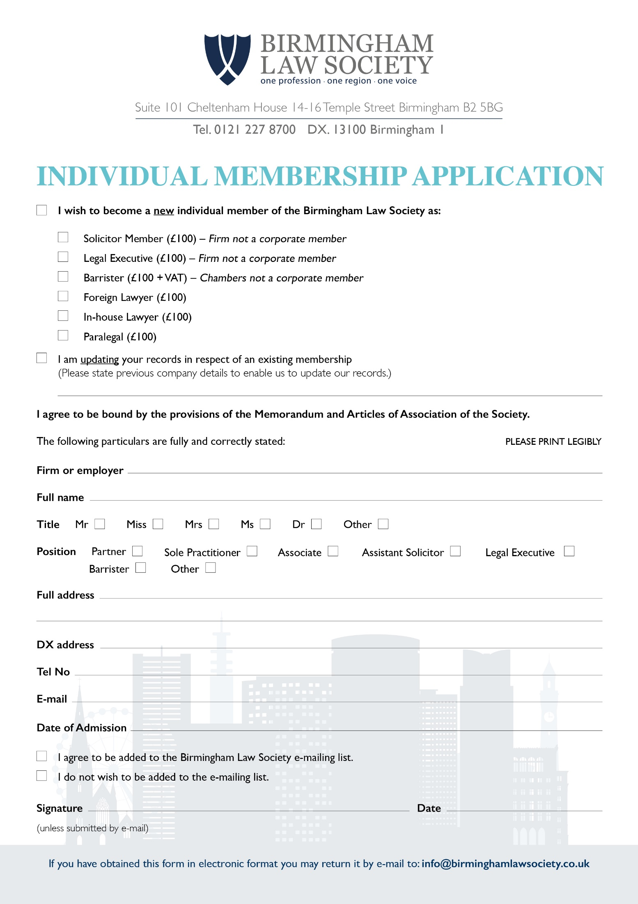
Schedule 3 – Membership Application Forms

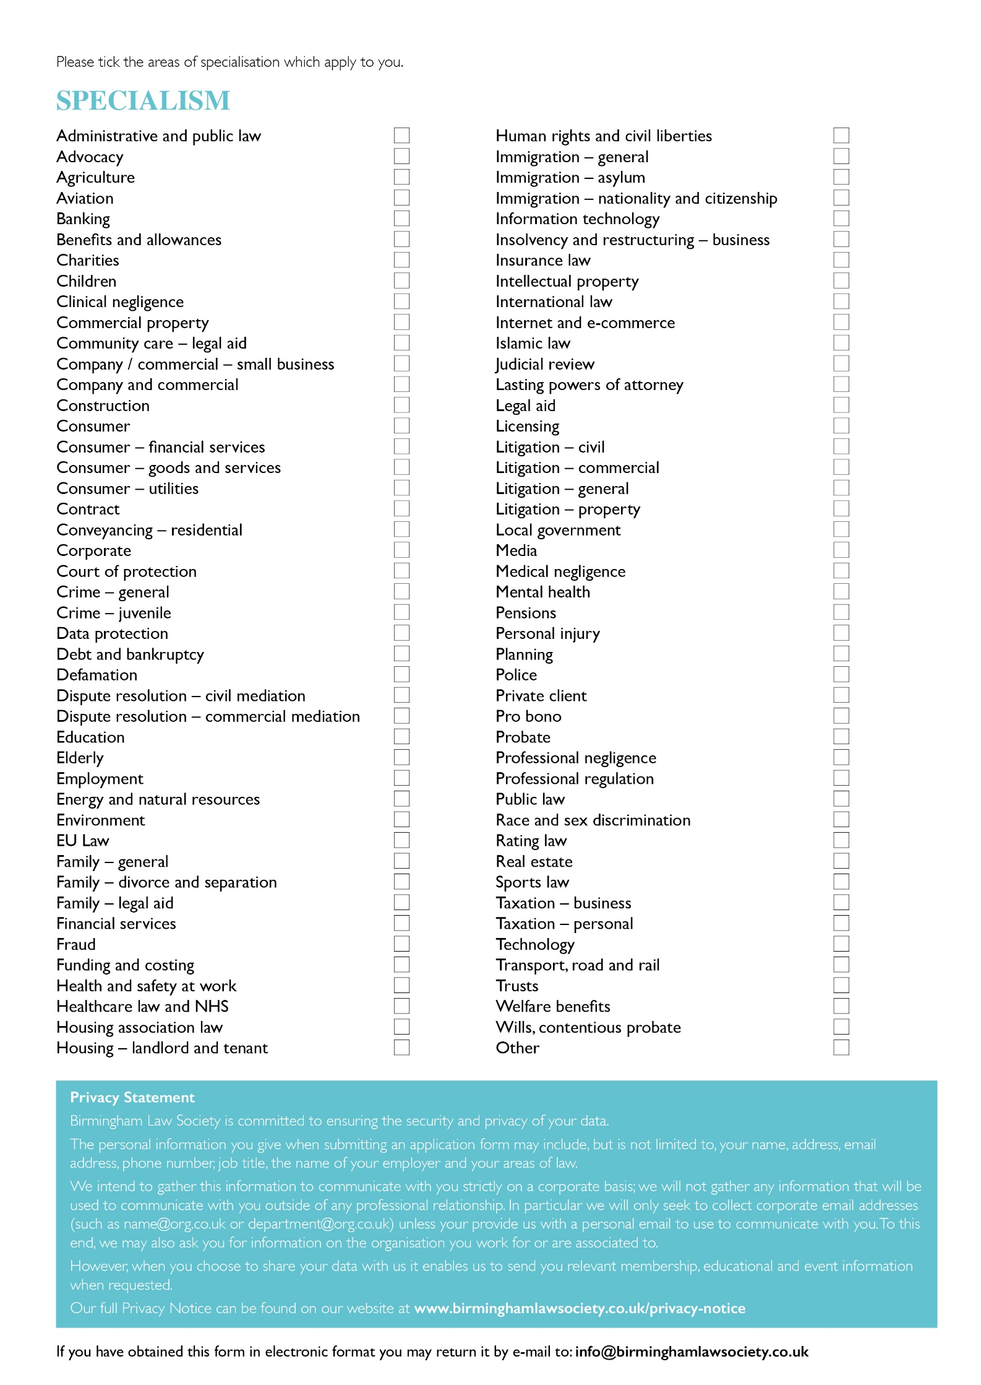
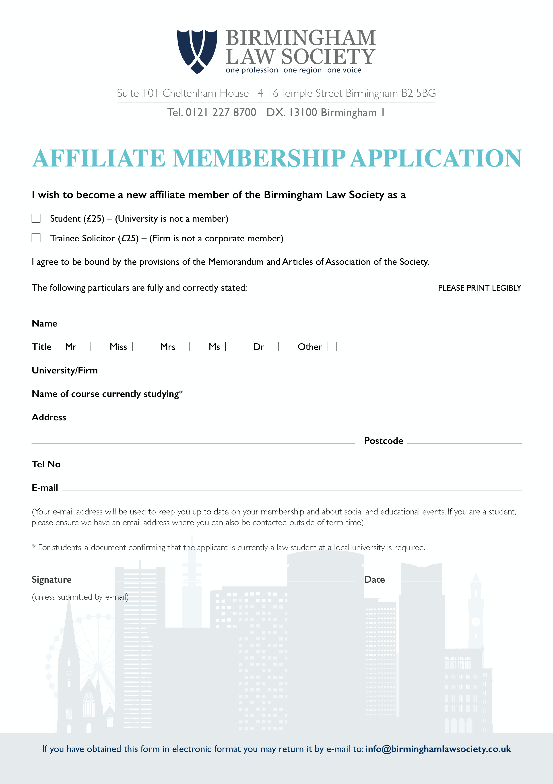

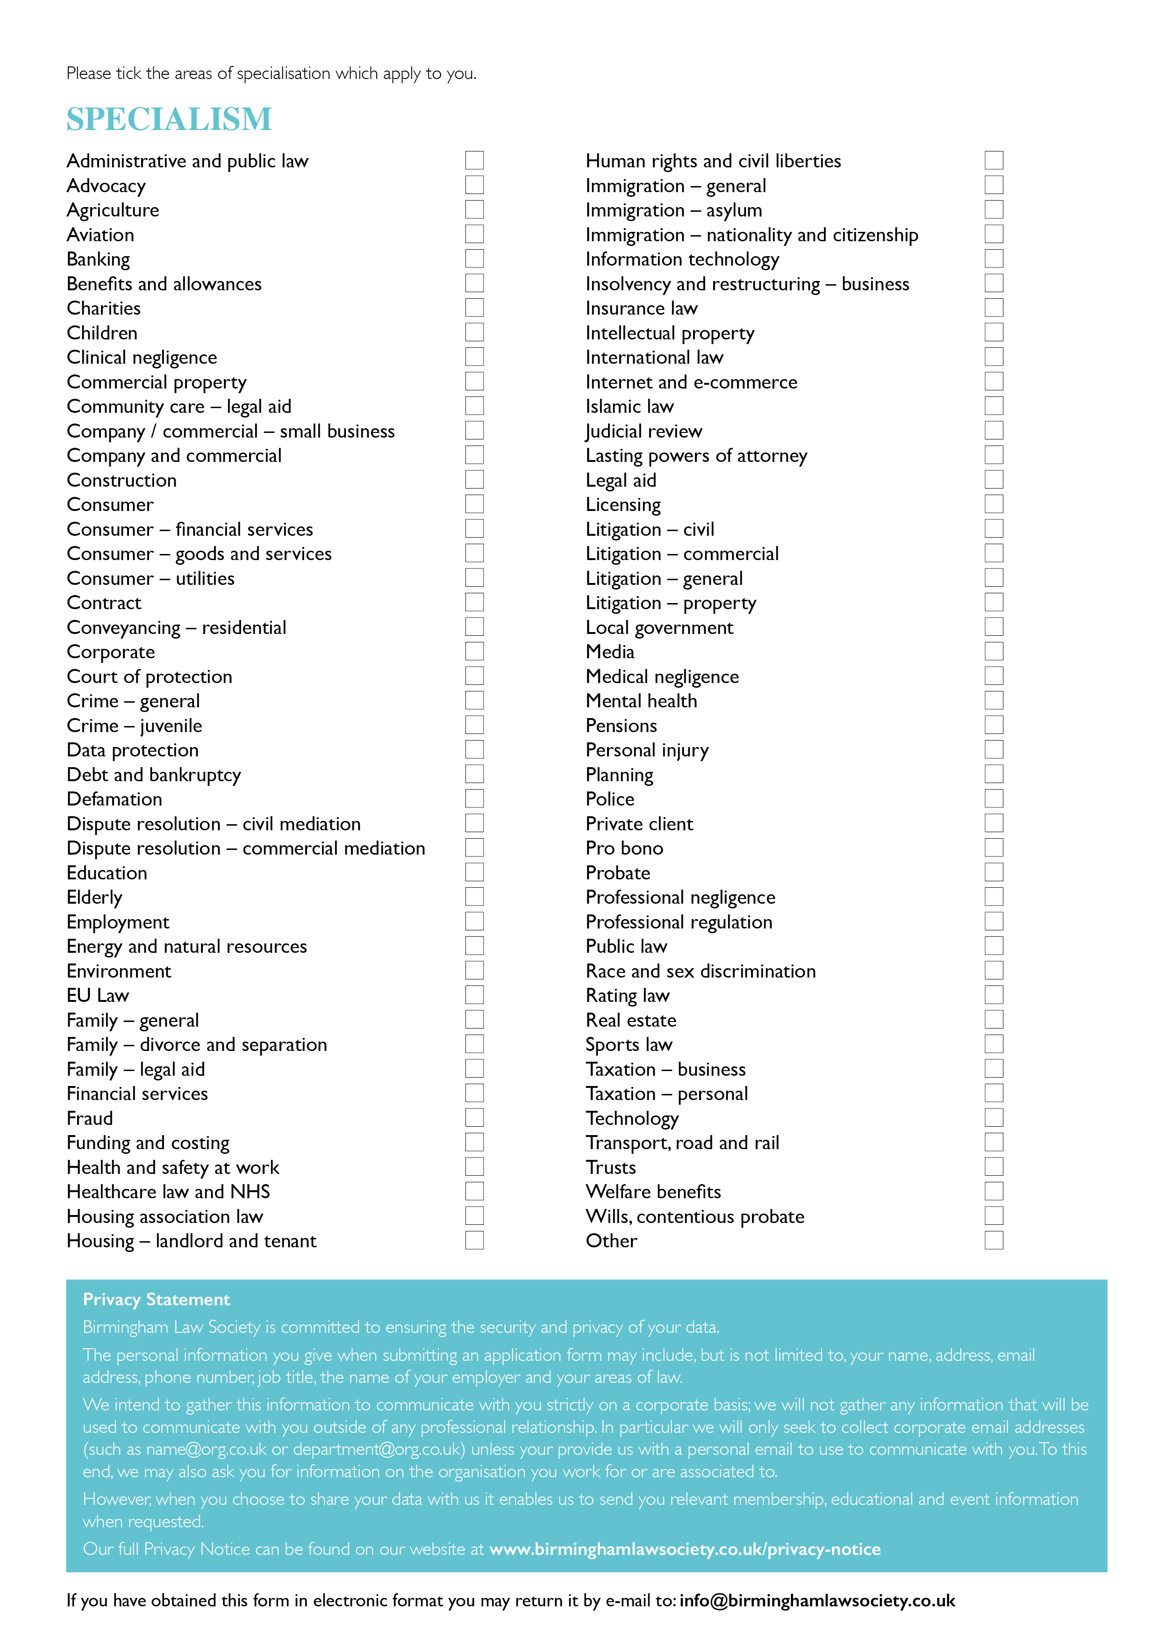

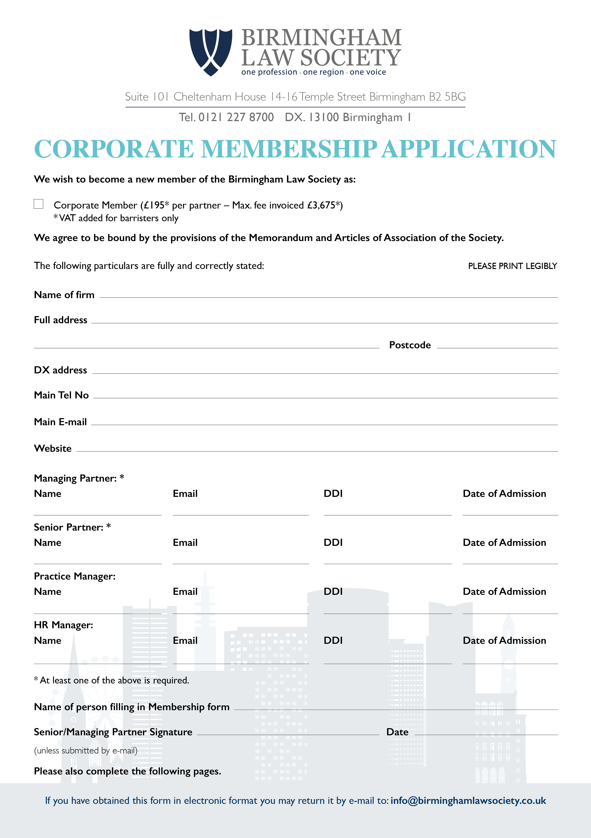

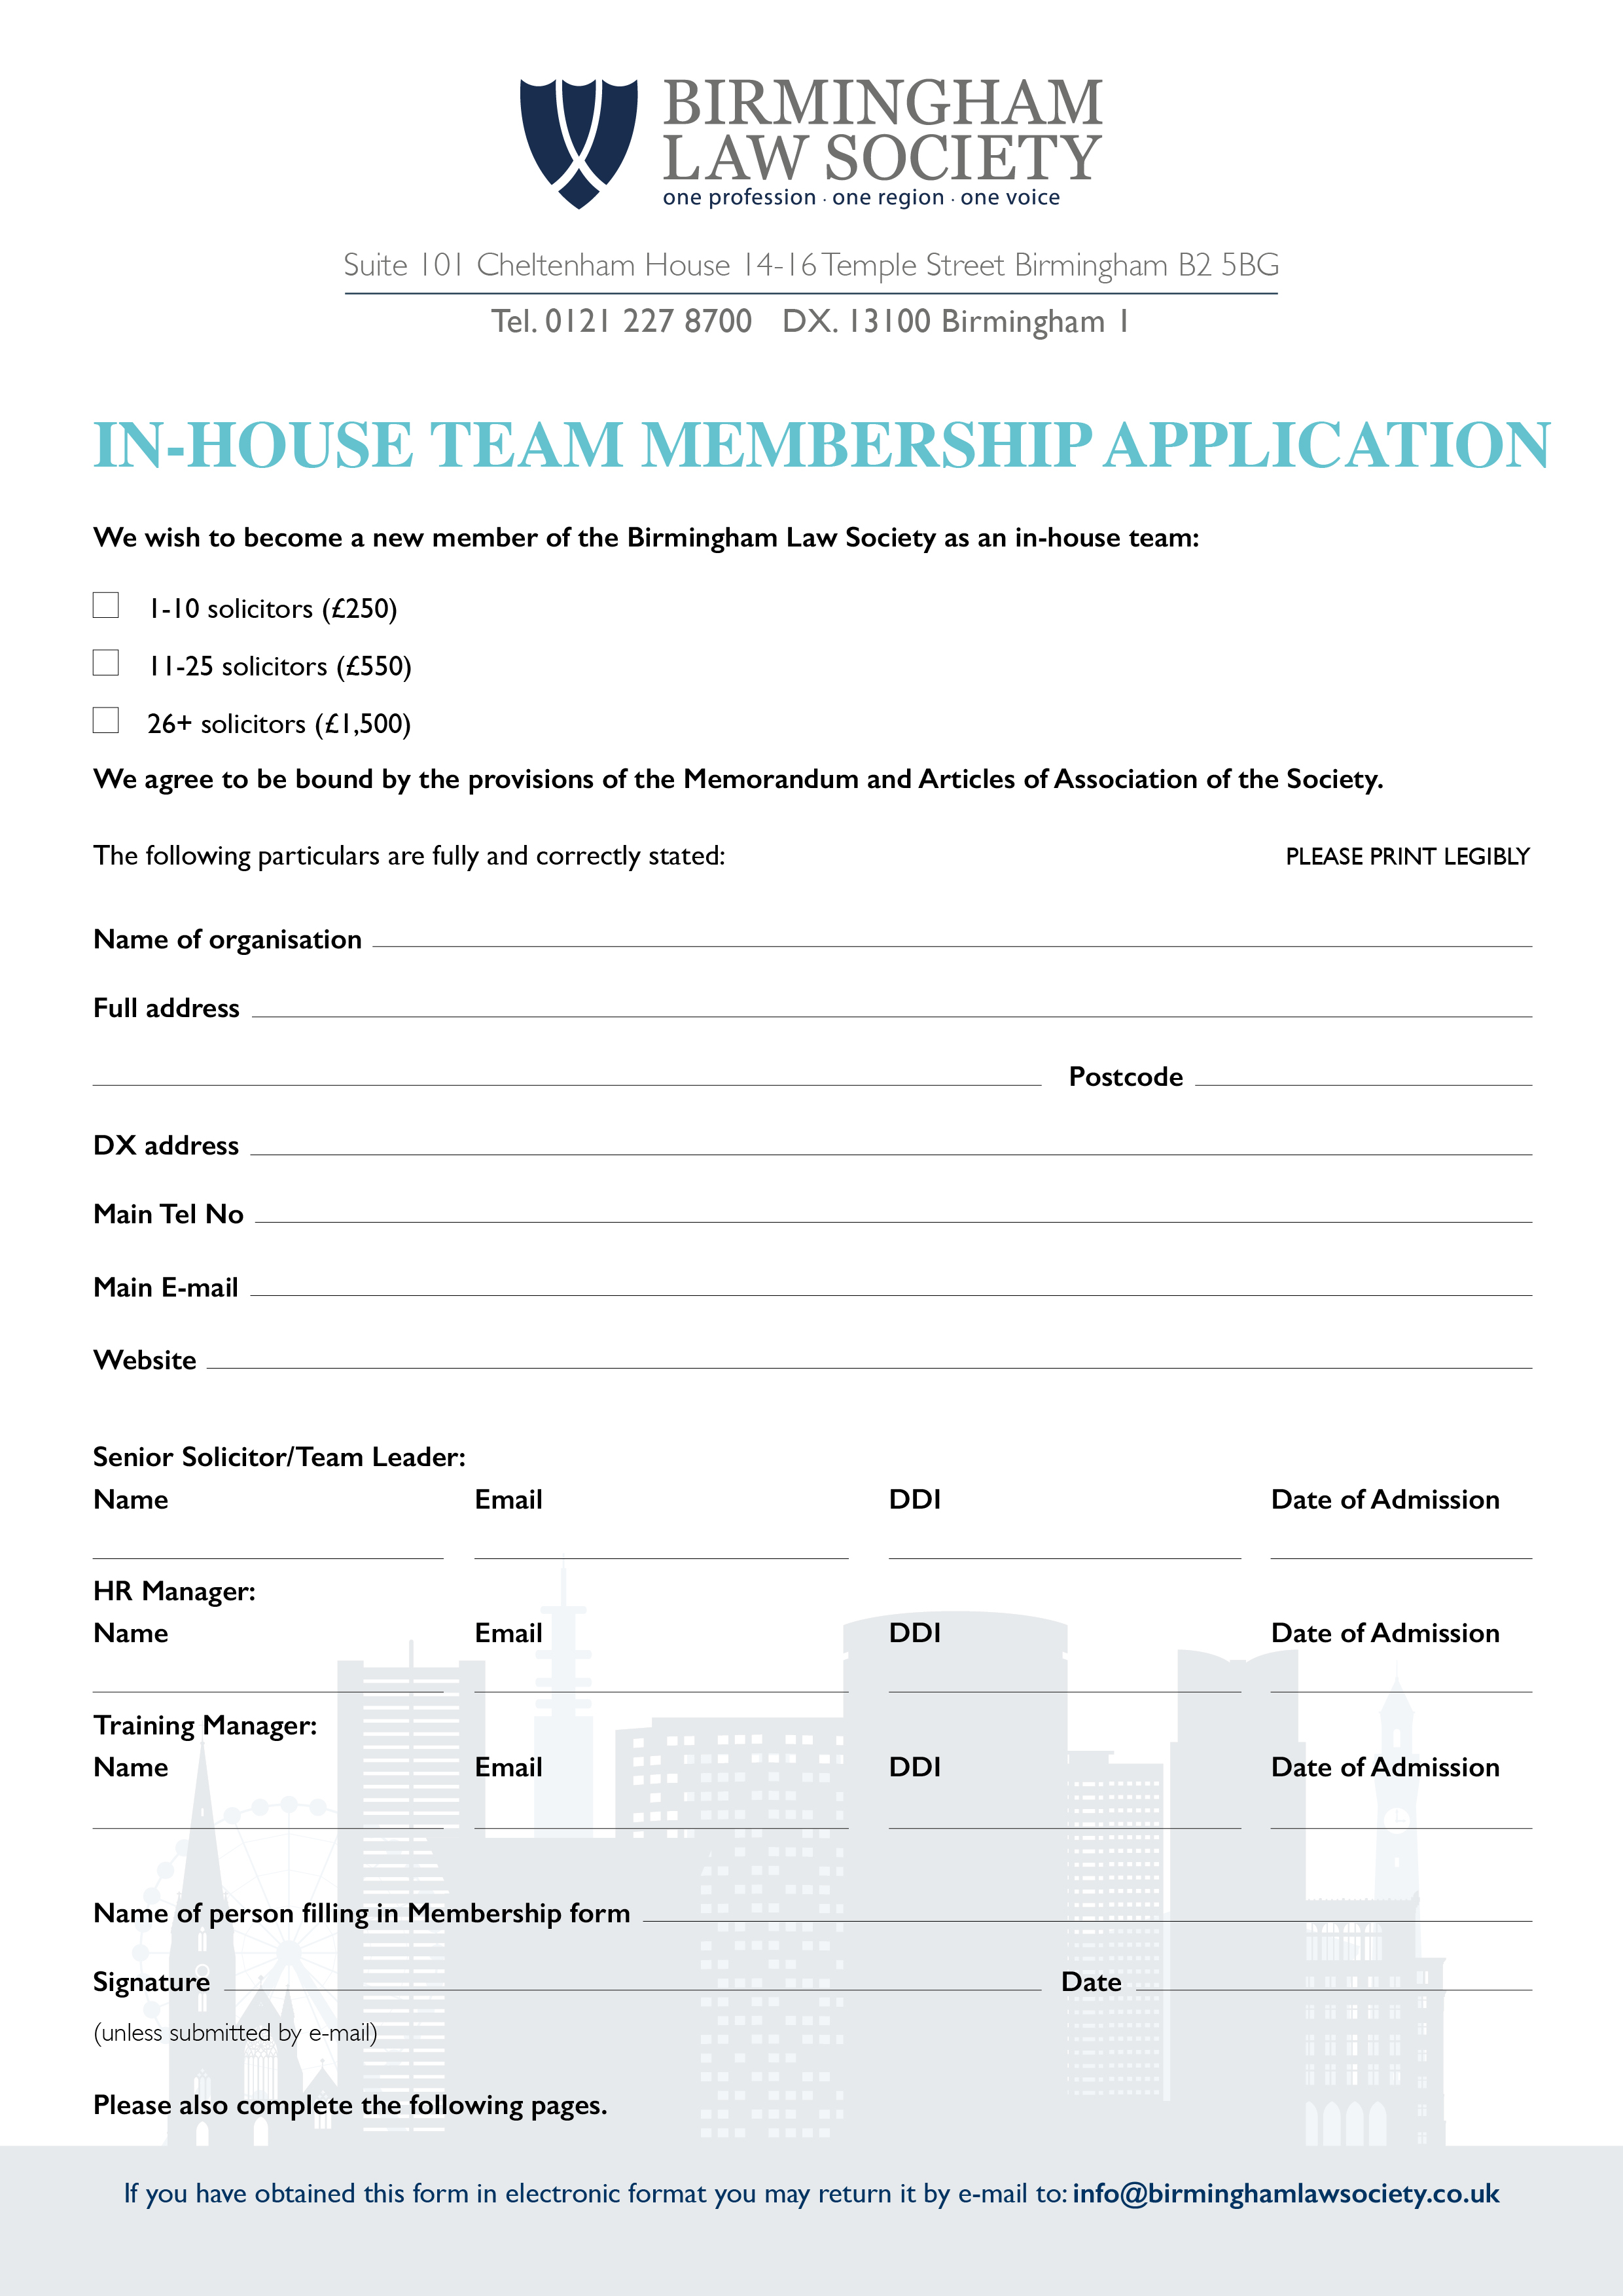

Schedule 5 – A Guide to Birmingham Law Society

A Guide to
Birmingham Law Society

This document is an introductory guide to Birmingham Law Society (BLS) for the Society’s volunteers, including Officers’, Directors, Council Members and Committee Chairs. Committee Chairs are encouraged to disseminate relevant information from this guide to their committee members as appropriate.
Contents
- Introduction to Birmingham Law Society
- Governance of Birmingham Law Society
- Officers
3.1 President of Birmingham Law Society - Role Description
3.2 Vice-President of Birmingham Law Society - Role Description
3.3 Deputy Vice-President of Birmingham Law Society - Role Description
3.4 Honorary Joint Secretary of Birmingham Law Society - Role Description
- Council
4.1 Council’s Function
4.2 Council Member Role Description
- Board of Directors
- Staff
- Committees
7.1 Committee Provisions
- Committee Chair – Role Description
- Representatives
- Protocol for Consultation Papers
- Responsibility for this Guide
Appendix One: Articles of Association

- Introduction to Birmingham Law Society (BLS)
Birmingham Law Society was established in 1818 and is now the largest local law society in the Country, representing over 5500 solicitors, barristers, legal executives, trainee solicitors, paralegals and law students in around 90 practices and four universities in Birmingham and the Greater Midlands area.
The Society is a membership based organisation. Its mission statement is as follows:
- We encourage closer contact between members thereby strengthening the regional legal community:
- by providing a programme for members including networking and activity based events;
- by holding public debates/discussions which are important to members;
- by establishing and maintaining effective lines of communication with all members.

2. We represent the professional interests of our members
- by direct representations and lobbying to Government, the SRA, The Law Society and other organisations;
- by engaging in consultations;
- by making use of the media;
- by encouraging links between the Society and our local politicians.

3. We promote the Society, our members and the region on the National and International stage
- by ensuring members are aware of the work which is undertaken by the Society;
- by ensuring all Officers, Board Members and Council Members promote the Society and its members whenever speaking to national or international organisations, including during international visits;
- by promoting the international relations, the Society has and establishing links.

4. We ensure our members are kept up to date with any important issues relevant to the legal profession
- by using any and all available means (electronic, seminars, newsletters, correspondence etc);
- by engaging in public debates/discussions with people associated with such changes;
- through training and other educational events.

5. We raise public awareness of legal issues relevant to the profession
- by promoting the rule of law and access to justice;
- by raising issues relevant to the provision of legal services such as Alternative Business Structures, cuts in legal aid, diversity issues in respect of access to the legal profession etc;

6. We are regarded as an integral and important part of Birmingham and the surrounding regions by ensuring close links with other organisations (both legal and non legal) including;
- national organisations such as The Law Society;
- local organisations such as Universities, Chamber of Commerce, Birmingham Forward, etc…
- local organisations involved in the administration of justice such as the Judiciary/Tribunals and the Police;
- Birmingham Trainee Solicitors Group and Birmingham Solicitors Group;
- Pro bono groups and charities.

7. We continuously consider providing services that benefit our members.

- Governance of Birmingham Law Society
Birmingham Law Society is a company limited by guarantee. Until 27 April 2010 the corporate governance of the Society was managed by Council and the Officers of the Society. In 2010 it was decided to separate the strategic operational arm of the Society by forming a Board of Directors whose responsibility it is to oversee and develop a robust and resilient business within the context of the day to day challenges. The President of the day is ex officio on the Board. The immediate Past President is also an ex officio of the Board.
The Officers, who are the ambassadors of the Society, have the day to day responsibility alongside the office team and Council to ensure that the strategies and policies of BLS are implemented.

- Officers
Birmingham Law Society's five office-holders are: the President, Vice-President and Deputy Vice-President and two Joint Honorary Secretaries. All appointments are subject to Council approval. The President, Vice-President and Deputy Vice-President each hold office for a year, running from the AGM in April. The Deputy Vice-President is elected by the Council by ballot and succeeds as Vice-President in the following year and as President in the year after that subject to confirmation by Council.
3.1 President of Birmingham Law Society - Role Description
Purpose of the role
- To champion and lead BLS.
- To represent BLS to all external agencies/bodies.
- To be an ambassador for the legal profession and BLS.
- To lead the Council of BLS.
Key tasks
[In addition to the key tasks of a Council member]
- To communicate with the legal profession and, in particular, with members of BLS Council.
- To be spokesperson for BLS.
- To represent BLS on ceremonial occasions.
- To build effective relationships with influential external bodies.
- To meet with sponsors and forge links with potential sponsors.
- To chair Council meetings.
- To chair the monthly Officers’ meetings.
- To build effective working relationships between the office-holders, Council Members, and Chairs of Committees.
- To attend Board meetings ex officio and to build effective working relationships with the Chair of the Board and the Directors.

3.2 Vice-President of Birmingham Law Society - Role Description
Purpose of the role
- To assist the President in all his or her functions, and to deputise for the President when necessary.
- To undertake such other responsibilities as may be delegated by the Council or the President.
Key tasks
[In addition to the key tasks of a Council member]
- To chair the think-tank, a group of Council members and Society members chosen by the Vice President to consider policy and the topical issues presenting to the Society.
- To build effective working relationships with Council members and the Chair of the Board and Directors of the Board.
3.3 Deputy Vice-President of Birmingham Law Society–Role Description
Purpose of the role
- To assist the President and Vice-President in all their functions and to deputise when necessary.
- To undertake such other responsibilities as may be delegated by the Council or the President.
Key tasks
[In addition to the key tasks of a Council member]
- To build effective working relationships with Council members.
3.4 Honorary Joint Secretary of Birmingham Law Society-Role Description
Purpose of the role
- To be responsible for ensuring support for the President and Council.
- To undertake and assist the BLS office in making the arrangements for the AGM, any EGMs and Ordinary Meetings of Council
- To assist the President, Vice-President and Deputy Vice-President at the meetings of the Officers
- To ensure that the Society works within the remit of the Articles of Association
Key Tasks
[In addition to the key tasks of a Council Member}
- To provide secretarial support for Council meetings, ensuring the agenda and meetings are produced on time.
- To provide support for the AGM and any EGMs.
- To provide secretarial and administrative support for the Officers’ meetings.
- To liaise with Birmingham Law Society staff, where appropriate.
- To attend other associated meetings, where possible, for example, Joint V meetings etc.
- To plan the annual cycle of Council and Officers’ meetings with the President, Vice President and Deputy Vice President.
- To work co-operatively with the other Honorary Joint Secretary, to share the work load, and ensure that cover is provided for the above tasks and duties.
- To provide any written reports as requested by the President.

- Council
4.1 Council’s function
The Society’s Articles of Association (included at Appendix One) provide that the Council shall be responsible for ensuring the Society runs its business in pursuance of its objects in accordance with terms of reference agreed between the Board and the Council from time to time.
The Council shall also decide Birmingham Law Society’s position on major policy issues.
  - Council Member Role Description

- To contribute to Birmingham Law Society achieving its objectives (as set out in the Articles of Association) through good governance and high quality, timely policy decision-making.
- To keep themselves informed of and up to date with members’ interests.
- To represent the views and interests of Birmingham Law Society members to the Society (for example, in discussions at Council meetings, by feeding into consultation responses etc).
- To keep themselves informed of Birmingham Law Society’s work and current issues.
- To communicate with members about Birmingham Law Society’s work.
- To promote Birmingham Law Society events and initiatives to members and encourage member participation and engagement.
- To be in a position to devote the necessary time to their work as Council members.
- To attend Council meetings (and other meetings, as appropriate) regularly; if absence from a meeting is unavoidable, to inform the responsible staff member in advance.
- To prepare for meetings and participate fully in decision making.
- To contribute to the Council’s work outside meetings, including through e-mail and discussion forums.
- To perform an ambassadorial and advocacy role for Birmingham Law Society.
- To work constructively with other Council members and staff.
- To engage proactively with the activities of Birmingham Law Society where appropriate, for example, through committee membership.
- To have an appropriate sense of stewardship of Birmingham Law Society’s assets and to be vigilant when considering proposals for expenditure to ensure that the proposal is financially viable.
The Society encourages the active engagement of Council members in its meetings and business. The Officers will review attendance of Council members and where a Council member has not attended three consecutive monthly Council meetings the articles provide for them to be removed from Council. It is common for Council members to have passed through a contested election and in such circumstances, it is important that those selected by Council actively contribute for the benefit of the Society.

- Board of Directors
All Directors of the Board are appointed and approved by Council for a period of 12 months renewable at the discretion of Council for up to three years. Any Director wishing to stand for re-election after three years may do so. The Board reserves the right, subject to approval by Council, to appoint further Directors to the Board, if it feels necessary, for the smooth running of the business of the Society.
The Board meets 10 times a year, and in the event of urgent business matters the Board may call an Extraordinary Board meeting.
Currently the Board consists of a Chairperson, Vice Chair and other Directors in the following roles: -
- Finance Director
- Committee Director
- HR/Equality and Diversity Director
- Marketing and Sponsorship Directors
- Learning and Development/ Education and Training Director
- Membership Director
- PR and Media Director
- Special Projects Director

The Roles of Directors

Chair of the Board
The Chair’s primary role is to ensure that the board is effective in its task of setting and implementing the Society’s direction and strategy working closely with the Director of Operations.
The Chair also sits as an Officer and a Council member to ensure the Societies business needs are met and to keep the Officers and Council members up to date on the Business strategy and decisions at Board.

Committee Director
The Committee Director will be responsible for overseeing the work of the Committees to ensure they contribute to the Societies Strategic and Business plan.
The Director will be responsible for holding regular meetings with the Chairs to maintain the relationship and keep the committees up to date on policy.
This will include, keeping in touch with each committee to keep up to date on their plans for the year including any events and any matters arising, holding quarterly Committee Chair meetings each a year, and reporting back to the Board and Council with full details on developments and support required.

Equality and Diversity Director
The Equality and Diversity Director deals with issues of equality, diversity and inclusion, both in Birmingham Law Society itself and in the legal profession more widely.
By providing information, advice and support, the Director helps progress initiatives that promote equality for all members of the profession, regardless of race, ethnicity, heritage, gender, age, religion, disability, sexual orientation or gender identity.

HR Director
The Director of Staffing is responsible for the overall supervision of the staff team. The Director of Operations manages the office team running the day to day business of the Society. The rest of the team consists of a Training and events Executive (full time), a full-time administrator and Social Media Lead, and a part time Membership Co-ordinator and an accountant (part time).
The HR Director supports the Director of Operations in the strategic oversight of the operational needs of the team to run an effective and receptive business office for the Society. The Director liaises with the Director of Operations, in particular, as to any issues which may arise and with input from the other Board Directors.
Urgent staffing matters are dealt with in between each meeting by the HR Director, the Director of Operations, Chair and, if appropriate, the President.

Finance Director and Vice Chair
The Finance Director is responsible for overseeing the finances of the Society with staff assistance from the Society’s in-house staff accountant, (currently Nigel Watson). At each Board meeting the FD produces a written summary of the financial position of the Society which is also copied to Council.
The finances of the Society include income from membership and sponsorship, income from education and training events and seminars, monies held on deposit, investment monies and interest on the same.
The expenses of the Society are monitored closely to ensure that the Society does not make a loss, in the recent past it has made a profit and the Board wishes for that to continue.
The current Finance Director also acts as Vice Chair.

Learning and Development/Education and Training Director
This role is currently under review to fit in with the Learning and Development Strategy. Further details to follow.
.

Sponsorship Directors
The Sponsorship Directors support the Director of Operations in planning the strategy for maintaining and increasing sponsorship and looking into new markets and raising the profile of the Society externally. The Director of Operations works with the Directors and takes the lead in identifying new organisations as potential sponsorship and develop contacts with potential sponsors and maintains existing relations with existing sponsors.
The responsibilities are to analyse the membership and benefits to the members; and actively, with assistance from the Officers, engage with the members and source new members.
Their roles and responsibilities are broadly to: -
- Support and maintain relationships with particular emphasis on retention of existing sponsors
- Engage with key target groups, identify potential new sponsors and assist the Society in maintaining the continuity of the relationship with the sponsors.
- Promoting the Society and raising its profile through a variety of channels
- Support the Director of Operations in ensuring the events are covered with sponsorship

In relation to sponsorship the importance of the role a President has to play each year cannot be underestimated. Each sponsor wants to meet the President of the day. Each President has a huge PR responsibility to keep all sponsors content.
Sponsorship is a vital source of income and for each event the Society holds it is essential that a sponsor is sought to cover the Society’s costs.

Membership Director
The Board’s Membership Director’s role and responsibilities are to analyse the membership and benefits to the members; and actively, with assistance from the Officers, engage with the members and source new members. The office lead on membership will be responsible for researching and monitoring the movements of law firms and in-house legal departments in and out of the region and to propose new members to target. By this co-ordinated means it is hoped that new members may be secured for BLS which will also assist this valuable income stream.
The Membership Director also monitors existing benefits and working closely with other Directors considers new benefits to maintain and attract new members.

PR and Media Director
The PR and Media Director’s role is to implement and maintain a PR strategy to include marketing, social media and membership/sponsorship engagement. The Director works closely with the PR agent (currently WPR) and the Director of Operations and the Social Media Lead to review and deliver the PR strategy.
This is a new role and currently includes a successful Membership engagement strategic plan which involves our members offering reactive PR pieces and giving them the opportunity to appear in the local press promoting their business as well as the Society.

The Society has successful increased its presence on Social media which has increased engagement with our members and contacts in the pandemic.

Each year the structure of the Board is reviewed to assess the strategic and business needs of the Board to effectively meet the operational requirements of the Society.
A copy of the Birmingham Law Society Board Business Plan is available from the Director of Operations upon request.

- Staff
Birmingham Law Society employs four members of staff. The team consists of:
- Rebecca Lynch, Director of Operations – becky@birminghamlawsociety.co.uk

Rebecca’s primary role is to manage the team of staff and the day to day business of Birmingham Law Society, working together with the Officers and the Board. The Director of Operations also sits ex officio in Council meetings and on the Board. Rebecca is also responsible for managing the Membership, Sponosrship and all of the Society’s social events, including the annual legal awards dinner. Rebecca reports to the Chair of the Board.

- Jess Uppal – Marketing an Events Manager – denise@birminghamlawsociety.co.uk

Jess’s primary role is to develop and manage the Social events and Marketing function for Birmingham Law Society, in order to provide quality events and training to the legal profession and to ensure that the business is commercial viable. Jess also supports the Director of Operations in day to day business requirements and works closely with the Director with responsibility for Learning and Development.

- Janet Abe - Administrative Assistant – janet@birminghamlawsociety.co.uk

Johanna’s primary role is to deal with the day to day running of the membership administration and database. Janet supports the team with all other administration duties.

- Shona Betts - Administrative Assistant - shona@birminghamlawsociety.co.uk

Shona’s primary role is credit control, general administration and administration of events.

- Committees
Birmingham Law Society has a number of committees, which bring together members who have a common interest in a particular practice area or topic linked to the legal profession. The committees carry out a significant amount of work on behalf of the Society and are a key way in which the Society connects with, and represents the interests of, its members.
The current committees are:
- Consultation Committee
- Criminal Law Committee
- Dispute Resolution Committee
- Education and Training Committee
- Equality and Diversity Committee
- Employment Law Committee
- Family Law Committee
- In-House Committee
- International Committee
- Legal Tech Committee
- Membership Committee
- Personal Injury and Clinical Negligence Committee
- Private Client Committee
- Pro Bono Committee
- Property and Development Committee
- Student Committee
Details of committee chairs and members can be found on the Birmingham Law Society website and are appended to the agenda for each Council meeting.
7.1 Committee Provisions
Committees are expected to adhere to the following provisions.
- Each committee should meet at least six times a year.
- It is good practice for the committee to set terms of reference detailing its scope and objectives. These may be updated by the committee as it deems necessary. Amended terms of reference should be shared with Council by way of a written update at the next Council meeting.
- Each committee should be managed by at least a Chair and a Vice Chair
- Committees are encouraged to appoint a committee secretary to take minutes of meetings, prepare meeting agendas in consultation with the Chair and Vice-Chair, keep committee membership and mailing lists updated etc.
- Each committee member should be a member of the Society unless they are not eligible and are invited onto the committee as a representative of another organisation.
- Committees should consider contributing to the Society’s Learning and Development programme by putting on events such as conferences and courses which will be of interest to members and will generate income for the Society. Suggestions for Learning and Development events, suitable speakers and topics should be discussed with the Professional Services Executive in the first instance.
- Committees are encouraged to consider inviting guest speakers to committee meetings.
- Committees should keep under review and promote to members changes in practice area/substantive law.
- Committee members are expected to:
  - raise the profile of BLS and the committee wherever possible;
  - forge closer links with external organisations, courts, tribunals etc;
  - support any request from the BLS Bulletin and/or staff for material/articles;
  - respond to all relevant consultation papers; and
  - assume responsibility for at least one project each year; and
  - support BLS events.

- Committee Chair – Role Description

Key tasks

- Identify agenda items for committee meetings
- Oversee recruitment of new committee members and ensure that there is a good mix of experience (i.e., types of practice area and size of firm, level of qualification) represented on the committee including ensuring all committee members are members of Birmingham Law Society
- Ensure good attendance and manage non-attendance at committee meetings
- Identify whether there are outside organisations with which it would be relevant and appropriate to establish closer links
- Assign responsibilities/tasks to committee members
- Act as the main point of contact for BLS staff, Officers, Council members and Directors
- Provide active programme for members which should include seminars, workshops, events and articles
Submit minutes of each committee meeting to the BLS office promptly after each committee meeting for circulation with Council papers and to add to website.
- Organise at least six committee meetings each year and keep the BLS office informed of dates.
- Provide reports to Council at the request of the President.
- Organise responses to consultation papers. Liaise with the Professional Services Manager on events, seminar and conferences ideas.
- Prepare a report for the Annual Report once a year in January.
Committee Chairs have the option to be co-opted onto Council. Where Chairs are co-opted they are expected to attend Council meetings on a regular basis.
Where a Chair chooses not to be co-opted onto Council, they will be expected to attend at least one Council meeting each year at the invitation of the President to report on the committee’s activities.
Chairs shall be required to stand for re-election each year (voting shall be by way of the relevant committee) and this will be the subject of approval by Council
Chairs will be required to step down at the end of a three-year term (unless there is no replacement for the Chair, whereupon the term shall continue a year by year basis)

- Representatives
Representatives are ambassadors from member firms and chambers with whom the Board, Officers and staff of Birmingham Law Society can liaise concerning events and issues arising.
The main role of a BLS representative is to promote the Society and its activities to colleagues within their firm. This may involve:
- encouraging colleagues to attend BLS events;
- ensuring details of upcoming BLS events are promoted via appropriate internal communications (on desktops, intranet etc);
- bringing events that are likely to be of interest to particular colleagues to their attention (for example, making sure the property team is aware of upcoming property seminars); and
- coordinating the firm’s participation at some BLS events (e.g., getting together quiz teams, teams for sporting tournaments etc).
- Assisting the Society to identify newly qualified Solicitors and Barristers retained by their firm/chambers.
Representatives are invited to meet with the BLS President and Officers twice a year at an informal networking event, where they are asked to give their feedback on the Society’s current offering and suggest ideas for future BLS events and initiatives. Representatives provide both a useful point of contact for BLS and also act as an ambassador for their organisation.
The role of representative is particularly suitable for junior to mid-level fee earners.

- Protocol for Consultation Papers
As set out in our mission statement, Birmingham Law Society represents the professional interests of our members by direct representations and lobbying to Government, the SRA, The Law Society and other organisations; by engaging in consultations; and by making use of the media.
Members are encouraged to contribute to consultation responses submitted by the Society and committees are expected to respond to consultations within their practice area.
The Chair of the Consultation Committee and the BLS office need to be informed by e-mail of any consultation papers in the pipeline. It is the responsibility of committee chairs to ensure that this happens.
Draft consultation responses need to be approved by the President and should be e-mailed to the President, preferably seven days before the consultation deadline, copying in the Chair of the Consultation Committee and the BLS office.
Once approved by the President, consultation papers will be submitted from the BLS office with the President’s name/signature.

- Responsibility for this Guide
The BLS Director of Operations has responsibility for ensuring that this document:
- disseminated to new Directors, Officers, Council members and committee chairs at the time of their appointment;
- reviewed and updated on an annual basis;
- circulated to existing Directors, Officers, Council members and committee chairs at least once every two years.
It is the responsibility of the BLS Officers to assist the Director of Operations with updating the content of this document.

Appendix One
[ARTICLES TO BE ADDED ONCE ADOPTED]

Schedule 5 – Committee Guidance
Committee Guidance
Committees are expected to adhere to the following provisions.
- Each committee should meet at least six times a year.
- It is good practice for the committee to set terms of reference detailing its scope and objectives. These may be updated by the committee as it deems necessary. Amended terms of reference should be shared with Council by way of a written update at the next Council meeting.
- Each committee should be managed by at least a Chair and a Vice Chair
- Committees are encouraged to appoint a committee secretary to take minutes of meetings, prepare meeting agendas in consultation with the Chair and Vice-Chair, keep committee membership and mailing lists updated etc.
- Committees should consider contributing to the Society’s Learning and Development programme by putting on events such as conferences and courses which will be of interest to members and will generate income for the Society. Suggestions for Learning and Development events, suitable speakers and topics should be discussed with the Professional Services Executive in the first instance.
- Committees are encouraged to consider inviting guest speakers to committee meetings.
- Committees should keep under review and promote to members changes in practice area/substantive law.
- Committee members are expected to:
  - raise the profile of BLS and the committee wherever possible;
  - forge closer links with external organisations, courts, tribunals etc;
  - support any request from the BLS Bulletin and/or staff for material/articles;
  - respond to all relevant consultation papers; and
  - assume responsibility for at least one project each year; and
  - support BLS events.

- Committee Chair – Role Description

Key tasks

- Identify agenda items for committee meetings
- Oversee recruitment of new committee members and ensure that there is a good mix of experience (i.e., types of practice area and size of firm, level of qualification) represented on the committee
- Ensure good attendance and manage non-attendance at committee meetings
- Identify whether there are outside organisations with which it would be relevant and appropriate to establish closer links
- Assign responsibilities/tasks to committee members
- Act as the main point of contact for BLS staff, Officers, Council members and Directors
- Provide active programme for members which should include seminars, workshops, events and articles
Submit minutes of each committee meeting to the BLS office promptly after each committee meeting for circulation with Council papers and to add to website.
- Organise at least six committee meetings each year and keep the BLS office informed of dates.
- Provide reports to Council at the request of the President.
- Organise responses to consultation papers. Liaise with the Professional Services Manager on events, seminar and conferences ideas.
- Prepare a report for the Annual Report once a year in January.
Committee Chairs have the option to be co-opted onto Council. Where Chairs are co-opted they are expected to attend Council meetings on a regular basis.
Where a Chair chooses not to be co-opted onto Council, they will be expected to attend at least one Council meeting each year at the invitation of the President to report on the committee’s activities.
Chairs shall be required to stand for re-election each year (voting shall be by way of the relevant committee) and this will be the subject of approval by Council
Chairs will be required to step down at the end of a three-year term (unless there is no replacement for the Chair, whereupon the term shall continue a year by year basis)

Schedule 6 – Terms of Reference

BIRMINGHAM LAW SOCIETY IN-HOUSE LAWYERS COMMITTEE

TERMS OF REFERENCE

Objects

To advance the mission of Birmingham Law Society in respect of the in-house legal community made up of practising and non-practising lawyers (including apprentices and trainees) from all sectors within the region served by the Society.

Membership

Membership will be reviewed regularly to ensure that representatives from all sectors are represented (or are invited to be represented) on the Committee.

The Committee will include the following appointed officers: Chair, Vice Chair. From May 2019, the term for the appointed officers will be 12 months with a review of appointments at the 11th meeting of the year.

Attendees

Any representative nominated by the Council of the Birmingham Law Society can attend meetings of the Committee by invitation.

Members of other Birmingham Law Society committees and the Birmingham Law Society Board can attend from time to time by invitation.

Quorum

At least half of the standing membership.

Frequency of meetings

Meetings will meet monthly (save for December unless required) and other meetings may be scheduled as required.

Authority

The Committee is authorised by the Council of Birmingham Law Society to undertake any activity within its terms of reference. The Committee is authorised to establish working groups what will be chaired by members of the Committee and be subject to their own terms of reference.

Purpose

To consider and make recommendations to Birmingham Law Society on the strategies and policies to develop the Society’s offering to the in-house legal community within the region served by the Society.

To be the specialist advisory group for Birmingham Law Society in respect of the in-house legal community within the region served by the Society.

To look inward, to the Birmingham Law Society, and help the Society to progress initiatives which ensure the progression, diversity and inclusion of the in-house legal community within the region served by the Society.

Objectives

The objectives of the Committee are to:

- raise the profile of the in-house legal community in the region by ensuring that Birmingham Law Society understands and caters for the needs of the community;
- nurture the in-house legal community in the region by creating a forum and opportunities for in house lawyers to network and share experience and best practice;
- develop the in-house legal community in the region through creation of networked and collaborative training and development opportunities to assist with organisations throughout the region in respect of recruitment, training and retention;
- ensure that Birmingham Law Society at all levels is relevant and representative to in house lawyers in the region; and
- respond to Government and other agency consultations on matters relating to the in-house legal community on behalf of Birmingham Law Society.
Reporting procedures
The Committee will report to the Council, Board and Officers of Birmingham Law Society regarding the work of the Committee and make recommendations to such bodies in respect of matters arising from its terms of reference. The minutes of the meetings will be circulated to members of such bodies on request.
Distribution of agenda and papers for meetings
The agenda and papers will normally be distributed to members a minimum of 3 days in advance of meetings.
Meeting procedures
Members may nominate proxies and meetings can be attended in person, by telephone or video conferencing.
Secretarial arrangements
A nominated secretary to the Committee will undertake the Committee’s secretarial duties.

Approved by the In-House Lawyers Committee on 4 February 2021 and ratified by the Birmingham Law Society Council on 24 February 2021
Private Client Committee
Birmingham Law Society

Terms of Reference

Objectives:-

- Our primary focus is the law and the legislative process relating to non-contentious private client practice (specifically: wills; probate and estate administration; wealth and inheritance tax planning; capacity issues (including powers of attorney and Court of Protection matters); and, trusts) and engaging with consultations relevant to those areas.
- Our core objective is to meaningfully and pro-actively represent non-contentious private client practitioners. We are a specialist committee committed to a representative role, seeking to pursue the best interests of non-contentious private client practitioners in the Birmingham and surrounding areas.
- We will exercise lobbying functions on behalf of non-contentious private client practitioners.
- We will work with like-minded non-contentious private client organisations (for example STEP, SFE, CIOT, ICAEW) in the Birmingham and surrounding areas on areas of common interest in meeting the objectives of this committee.
- We will develop up-to-date professional advice on selected non-contentious private client matters that will be of interest to practitioners in Birmingham and surrounding areas, which may include organising specialist training, professional development and / or networking events.

The committee will:

- Have 10 meetings a year (monthly, aside from August and December).
- Meetings to be held on the first Monday of each month.
- Be supported by a committee chair (in turn supported by a deputy chair) who is responsible for driving forward initiatives agreed upon by the committee.
- Make a record of the meetings to be circulated for consideration by Council.
- Provide a forum for committee members to share ideas and issues regarding best practice and raise queries and points for discussion.
- Invite guest speakers to come and speak at our committee meetings, to share ideas, opportunities and updates at committee meetings.
Birmingham Law Society Pro Bono Committee
Terms of Reference
The pro bono committee’s objectives are to:
- support;
- promote;
- signpost; and
- raise the profile of pro bono work amongst Birmingham Law Society (BLS) members and the local community.

The committee will:
- keep an up-to-date database of sources of free legal advice and support for members of the public to access on the BLS website;
- signpost members of the public who approach BLS to sources of free legal advice and support;
- provide a forum for committee members to share pro bono best practice and raise queries and points for discussion regarding pro bono practice with one another;
- invite guest speakers to share pro bono information, best practice, opportunities and updates at committee meetings;
- ensure that committee membership is reviewed regularly and local firms, chambers and relevant third sector legal organisations are represented (or are invited to be represented) on the committee;
- host an event during National Pro Bono Week each year to promote pro bono opportunities to Birmingham Law Society members;
- proactively help to build links between local third sector advice agencies and local legal practitioners for the purposes of delivering pro bono advice; and
- host; co-host; and/or support external facing events relating to pro bono and public legal education as appropriate.

Dispute Resolution Committee
Birmingham Law Society

Terms of Reference

Objectives:-

- Our primary focus is around civil procedure, the civil courts and engaging with consultations relevant to those areas.
- Our core objective is to meaningfully and pro-actively represent dispute resolution practitioners. We are a specialist committee committed to a representative role, seeking to pursue the best interests of practitioners in the Birmingham and surrounding areas.
- We organise specialist training, professional development and networking events.
- We exercise lobbying functions on behalf of practitioners.

The committee will:

- Have 10 meetings a year (monthly, aside from August and December).
- Be supported by a committee chair (in turn supported by a deputy chair) who is responsible for driving forward initiatives agreed upon by the committee.
- Make a record of the meetings to be circulated for consideration by Council.
- Provide a forum for committee members to share ideas and issue regarding best practice and raise queries and points for discussion.
- Invite guest speakers to come and speak at our committee meetings, to share ideas, opportunities and updates at committee meetings.

Schedule 7 – Professional Committee Chair Pro-forma Report

To be completed.

Schedule 8 – Event Support for Committees Guidance

Birmingham Law Society Event Support for Committees

Covering Note for Briefing Form

The Society has a small administration team (team members listed below) to support the Society and due to the large number of committees (16 in total), the resource in the office is limited in relation to the support that the office can offer for committee events. The administration team encourage the committees to organise events following the guide below.

BLS Office team

Becky Lynch – Head of Operations - 0121 227 8704

Inviting Birmingham Law Society Officers to attend

All Officers are invited to attend committee events where relevant, if there is an opportunity for the President to do a welcome/introduction, please include this in the briefing form, if the President is not able to attend to do the welcome, the Officers will be asked the following order - VP, DVP and Chair.

Notice for events

- The event Briefing form must be completed as best you can and returned to the office as soon as possible (the briefing note is attached to this document)
- A call/meeting will be arranged to discuss your requirements
- Please let us know the proposed date asap and check with the office to avoid any clashes asap
- Please ensure the event arrangements are agreed and the event is ready to market to the membership at least 6 weeks prior to the date of the event

Venues

The office will assist with sourcing a venue where possible, if the Committee can assist with finding a venue via the committee first, that would be preferable as the office has a number of venues to source for the general events and relies on the membership to host the majority of events. If assistance is required, upon confirmation of the date for the event, the Training and Events Executive will contact venues for availability and maximum numbers and can support the committee with the following items:

- Liaise with venue with regards to set up and refreshments
- Be on hand on the day of event
- Organise for a BLS stand to be present at the event
- Sign people in, name badge (depending on restrictions post Covid)

Marketing

The office will organise the marketing for the event and prepare the following and be responsible for supporting the marketing for the committee:

- Create an event flyer once marketing materials and requirements have been supplied by committee will be used to create an event page on www.birminghamlawsociety.co.uk
- Where applicable, the events promotional video will be shared on Social media
- Weekly email sent to membership promoting event (targeted to area of law if applicable) either as a single event or part of the e-newsletter
- The event details will be sent to BLS Ambassadors, Board and Council to promote to their contacts
- Where applicable, a “Thank you to our kind sponsors…” - tagged in post on social media
- Event flyer and booking link posted on Twitter, Facebook and LinkedIn in weekly
post
- Event shared live on Facebook, Instagram,
LinkedIn and Twitter stories Birmingham Law Society
- Screenshots/photos taken at the Event to be shared on Twitter, Facebook, LinkedIn and Instagram
- Bulletin write up to be included in magazine (subject to bulletin release date) and shared on website and social media. Where the event has been recorded a link will be shared on Twitter, Facebook, LinkedIn and will be accessible through the Birmingham Law Society event galleries page (example here)
- The committee members should support the marketing by sharing across their platforms and contacts to ensure good attendance.

Sponsorship

If you are looking for sponsorship, we normally ask the committees to organise this as the Committees will be best placed in knowing what organisations may support the event however if you need any help, the office is happy to advise and share information of our current sponsors if appropriate or make approaches if introductions are made. Once the Sponsorship is agreed, this can be passed to the office to organise an agreement and an invoice and to ensure their needs are met.

Cost/Budget

All events must be covered by sponsorship or ticket price, the Society does not have a budget for events and training. This should be in place before agreeing to market the event to ensure no losses are made. Currently the Society is offering many events free of charge for members due to the pandemic however this is under constant review and will change at some point in the future. All non-members must be charged a fee, or the event must be members only unless there is an arrangement with a partner/sponsor. All events should break even or make a profit.

Event Briefing form
Thank you for your interest in running an event for the benefit of our members. To ensure the BLS team provides you with appropriate support in the creation, marketing and delivery of the event, we would be grateful if you would complete this form with as much detail as possible.

Should you have any queries on how to complete this form, please do not hesitate to contact Jess Uppal, Marketing & Events Manager on 0121 227 8703 / 07809502852 / jess@birminghamlawsociety.co.uk or your main contact (if different).

The BLS team includes many people including our amazing office staff, our committed council members and our diligent directors, all of whom may play a part in assisting with your event. To ensure effective means of communication, we have appointed you one main contact who will assist you throughout your event planning. Your main contact will liaise with the BLS team on your behalf, meaning you only need to keep one email address handy!
Your main contact is: Jess Uppal

Information we need from you:

 |  | ABOUT YOU
Name: |  |  |  |  |  |  | Role:

Company Name:

Email:

Telephone Number:

EVENT DETAILS
Event Title:

Date and Time of Event:

Name and Job title of event Speaker(s):
Main Objectives of the Event:

Benefits to BLS Members:
Member and Non-Member Ticket Price (if applicable):

Who is the event aimed at? i.e., a specific area of Law, level or job title

Expected number of participants:

Is there a charity element for the event, and if so please add details here:

Do you have event sponsors? Please include the details here.

Have you checked that the date does not clash with any other BLS events? |  |  | Yes No  [If you have not checked that the date of your proposed event does not clash with any other BLS event, please contact your main contact who will be able to provide further advice]
How will the event be delivered? |  |  | In-person  Please confirm the venue: ______________________  Virtual  Please confirm the platform: ____________________  I am happy for this event to be recorded, and uploaded to the BLS website:  Yes No  I would like to use the BLS Zoom* account:  YES  *Please note: If you are planning to use another platform for your event, BLS will be unable to provide this  If yes. I would like this to be in the following format:  Zoom Webinar (participants hidden from screen)  Zoom Meeting (participants visible on screen)
Will you require additional technology? |  |  | [For example, polls or live Q&A sessions. If so, please confirm the poll questions that you would like to ask or alternatively, the dates for when you will provide the poll questions to us]
What support do you need from the BLS Office Team on the day of the event?

Do you require the BLS President to attend the event? If so, what is required from them (i.e. welcome, introduction)

Would you like BLS to prepare the marketing materials for the event? |  |  | YES  NO (I will provide the marketing materials for BLS to circulate to the membership)  Please confirm any specific wording you would like used in the marketing materials. If none is provided, the BLS team will prepare this:  __________________________________________  __________________________________________  __________________________________________
Social Media Handles (please include all charity, company, speaker etc. handles to be included): |  |  | Twitter:  @  @  @  LinkedIn:  @  @  @  Instagram:  @  @  @  Facebook:  @  @  @
Please let us know any additional information that would be helpful for us to assist you with your event:

Before you send this form back, have you attached  (1) your company logo  (2) any photos that you would like to use in the marketing of the event (for example, speaker photos)  (3) any wording that you would like to include in the marketing of the event |  |  |  |  |  |  |  |  |  |  | Yes |  | No

