Council Election Nominees

Guy Barnett

Background
I graduated in Law from the University of West of England in 1986 and qualified as a solicitor in 1991. I joined Blakemore’s in 1989 and led the Automotive & Personal Injury Department as a specialist in automotive disputes, asset finance, consumer law and personal injury cases. I later became Manging Partner and was founder of the innovative national marketing brand “Lawyers2you”.
I was an active member of the Birmingham Legal Community between 1989 – 2012. As well as being a Birmingham Law Society Council member between 2004-6 and attained the following awards: -
- Managing Partner Law Firm of the Year 2006 Birmingham Law Society
- Shortlisted, Birmingham Forward Inspirational Leader of the Year, 2007
- Managing Partner Law Firm of the Year 2007 Birmingham Law Society
- Solicitor of the Year 2007 Birmingham Law Society
- 360 Legal Awards, Innovator of the Year, 2010
In 2013 I became a specialist management, governance and inhouse consultant, undertaking a variety of international roles in sectors such as architecture, recruitment, charities, private finance initiatives as well as in business turnaround situations.
In these roles I gained extensive experience in dealing with all practical and legal aspects of commercial management including: -
- Strategic Planning & Leadership
- Business Development & Revenue Growth
- Key Stakeholder Relationship Management
- Operational Management & Control
- Communication and public speaking
- Recruitment & Talent Acquisition Strategies
In 2021 I returned to Birmingham and private practice to become the Regional Head of Axiom DWFM, responsible for its offices in both the East and West Midlands.
I spend MY spare time with his young daughter. He is an accomplished showjumper and was Welsh Amateur Champion 2009. He is a former member of the Reserve Armed Forces having attained the rank of Company Sergeant Major. I also play for a professional paintball team.

Reasons to be elected
I have been an active member of the Birmingham legal community since 1989 and as such have a deep understanding of the issues affecting the profession both regionally and nationally.
I am passionate about representing its members across a broad range of spectrums, whether they work in large organisations, sole practitioners or as in house counsel.
Having previously been a council member between 2004-06 I am fully aware of the role and responsibilities involved and the time commitment needed to be an active member.
In role I would wish to bring me transferable skills in the following areas-
- Strategic Planning: Focusing on developing strategies that invest in future sustainable business success for the Society by presenting sound business cases supported with strong evidence that would grow the membership and sponsorship base.
- Business Development & Revenue Growth: Conducting a structured approach to determining the best methods for gaining competitive advantage and stronger performance by finding unique solutions to static problems and creating radical income streams.
- Key Stakeholder Relationship Management: Firm believer in participative style of engagement to encourage ideas & good decision making at all levels. Helping identify and develop the needs & address the issues of its members.
- Communication: Consistent, clear, inclusive & fact-based communication style. Influences internal & external stakeholders by considering other viewpoints & drivers when deciding most appropriate communication method & content. Media trained with a flair for keynote speaking & presenting

Should I be elected, I am confident that I have the transferrable skills needed to grow the membership base of the Birmingham Law Society. With my commitment to implementing new approaches to the membership structure and changing the event organisation to involve both the younger generation of upcoming law professions and trainees with Birmingham based firms of all sizes to network together to expand law in Birmingham, this in turn would encourage sponsorship from third parties and revenue from both.
I have strong belief in encouraging and involving younger members of the profession in future activities and events with the Birmingham Law Society by producing new networking opportunities that are both fun and educational, which encourages individuals to continue with their membership throughout their careers.

Simon Harris

Background
I am a Senior Associate in the Commercial, IT and Outsourcing Team at Gowling WLG, specialising in public procurement and government outsourcing. I have been at Gowling for over 5 years and have worked on a range of diverse public sector projects during this time. Gowling were recently reappointed to the Crown Commercial Services Panel, and this forms a core part of my work. Please see link to my Gowling profile for further detail around my experiences to date – https://gowlingwlg.com/en/people/simon-harris/#panel-button1.
I qualified as a solicitor through the CILEx route in 2018, and I can bring this different experience to the Society.
I previously worked as a Paralegal at DAC Beachcroft, where I was part of the insurance litigation team, acting on behalf of insurance companies.
During my law degree, I spent a summer in North Carolina working on post-conviction capital cases where the law firm appealed sentences on the basis of the jury selection process.
Aside from law, I enjoy gardening and (unfortunately) have a season ticket at West Brom.

Reason why I should be elected
As a Council Member, I will promote the work of the Society within Gowling and encourage participation at events, being the point of contact for the Society within the firm. I will actively engage in meetings, ensuring that views from within the firm are articulated, and there is feedback on discussions held.

Harriet Muffett

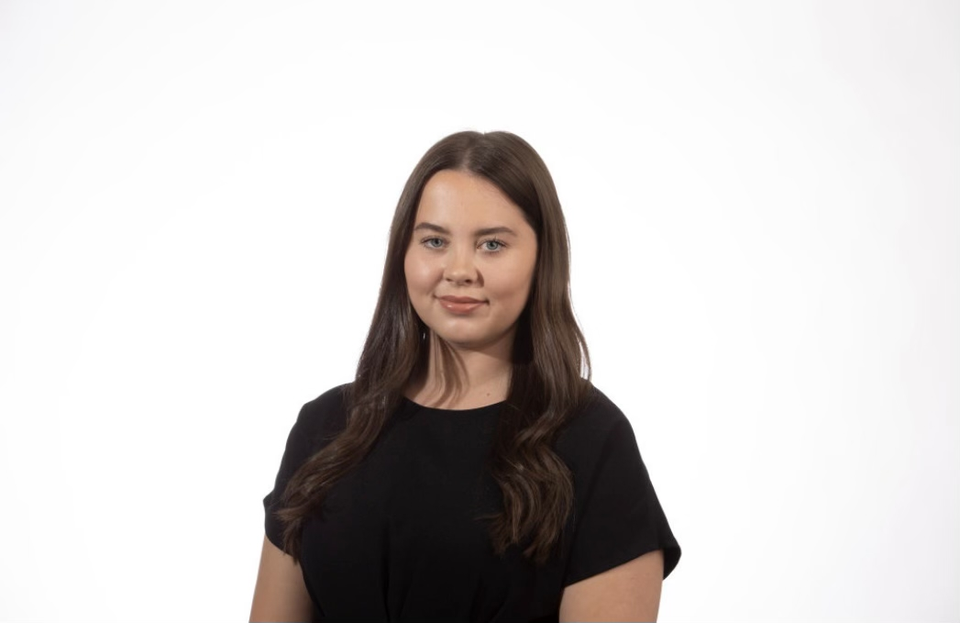

Background

I grew up in Solihull and began by LLB at the University of Birmingham in 2014. After graduating in 2017, I decided to study the joint LPC LLM at the University of Law.

Throughout my studies and during my training contract I volunteered with criminal law charity APPEAL. APPEAL provides legal representation to those who believe their convictions are/were unsafe and campaigns for system reform. I continue to involve myself in areas outside of my specialism and advocate for those who need support. Other projects I’ve been involved in include delivering training on criminal offences to Women’s Aid staff with the Centre for Women’s Justice. I am also currently in the process of training with the Schools Consent Project team to deliver sessions in schools around the Midlands.

I qualified as a Solicitor on 6 January 2021.

In April of this year, I moved from Freeths LLP to Trowers & Hamlins LLP and currently practise as a Dispute Resolution and Litigation solicitor, specialising in property litigation.

In 2021, I obtained higher rights of audience, and I am continuing to develop my advocacy skills wherever possible.

Outside of the law, I am a keen runner and I’m due to take place in the 2023 London Marathon for Heart Research UK.

Reasons why I should be elected

As I have demonstrated through my voluntary work to date, I am particularly passionate about access to justice and advocating for disadvantaged or under-represented groups. I feel that as a Birmingham Law Society (BLS) Council Member, I would be able to voice the opinions of these groups and keep them at the forefront when BLS is making key decisions. I would also like to get involved with the pro-bono initiatives and other committees run by BLS.

As a relatively newly qualified solicitor (6 Jan 2021), I understand the importance of having young lawyers as Council members. I would like to work with local firms, universities, colleges and perhaps even schools to encourage young people from all backgrounds to consider a career in law. I believe it would be helpful to work with young people to understand the challenges that face them when they consider a legal career and how these challenges can be overcome.

The importance of organisations like BLS is highlighted by the current Criminal Bar Association strikes. As a Council Member, I would like to support our lawyer colleagues (both those at the Bar and fellow solicitors) in voicing what matters to them. I think it’s important that we also work collaboratively with other professions to make sure that a career in the law remains viable and desirable for all.

I’m a confident and open-minded individual and I believe I learn best by hearing different opinions and points of view.

I hope to connect with and learn from other legal professionals through the Council, Committees and at BLS events.

Matt O’Brien

I am a solicitor and partner at Jonas Roy Bloom. I have been practising criminal law at the firm since 2003, starting as a paralegal and working my way to qualification as a solicitor, and then partner. In that time, I have developed close relationships with people throughout Birmingham’s close-knit and thriving legal community, both within and without the criminal law. Inspired by my firm’s long association with Birmingham Law Society, I am now proudly serving my fourth year as Chair of the Criminal Law Committee. By virtue of my chairship, I have served as a co-opted Council member since 2020. I mainly defend in white-collar crime and regulatory prosecutions, and also specialise in acting for defendants with mental health and cognitive conditions.
If elected to Council, Birmingham Law Society will benefit from the same creative and collaborative problem-solving approach that I bring to my client-facing work. I will bring the same dedication to Council that I have to the Criminal Law Committee for over three years. As Committee Chair, I have a proven track record of promoting the Society, having spoken on its behalf at numerous regional events, and having been the co-author of several consultation responses. I am passionate about inspiring a talented and diverse new generation of lawyers, and I believe that the Society has a fundamental role to play in doing so within the region: as Council member, I will work to promote that role.

Amrik Singh

Background
I am a Family Law Solicitor at Greens Solicitors. Prior to commencing a career in Law, I worked within the Insurance and Banking sector. I began my legal career in 2015 at a firm based in the East Midlands. I qualified as a Solicitor in 2021 specialising solely in family law. I currently practice in both private and public areas of Family Law with a heavy focus on complexed matrimonial finance matters and children act matters. I am also an experienced accredited police station representative and I regularly represent clients for at the police station for an array of criminal offences.

Outside of my legal work, I spend a lot of my time volunteering for local charities. My most recent appointment includes my role as General Secretary sat on the Management Committee of a charity based in Warwickshire where I have completed a 15-month term. The charity Sikh Mission Centre is a long-standing charity with almost 30 years standing within the community. The charity offers services to all ethnic minority residents in the West Midlands and Warwickshire area. Following a successful campaign, I was elected to serve as the General Secretary of the charity where I managed the charity’s financial accounts and assets, the charity’s employees and the charity’s public relations. I also worked closely with our members to ensure their voices and views were heard by the committee.

I have a true desire to help other people and I am very excited to continue my work in the future and work on new projects and opportunities that may arise.

Why I should be elected
As someone who has lived and worked within the Midlands for all of his life, I have developed strong connections with numerous legal professionals across the county. I genuinely care about our profession and want to play a part in its promotion and growth. I am thoroughly motivated to take on this role and can ensure that I will bring a lot of enthusiasm and commitment to it.

I have also completed work with local universities assisting law students with their pathway into Law and I have worked alongside various other firms and professionals including Birmingham Law Society itself. I have done this both locally in Birmingham but also on a national scale where I have worked closely with firms in Nottinghamshire, East London and Liverpool. I am confident that the relationships I have formed will ensure that I am effective within my role.

Aside from my motivation and connection to the legal profession in the Midlands, I also have the experience required to be an effective council member for Birmingham Law Society. As mentioned already, I have recently completed my term as General Secretary at the Sikh Mission Centre. I represented the voice of approximately 150 members. I have also demonstrated my ability to make decisions surrounding policy making, procedure and expansion. Whenever making these decisions, I have had to consider the finances of the charity to ensure that any expansion is viable and cost effective. While doing this, I have demonstrated my ability to be accountable to my members and to work under pressure.

I believe that I would make an excellent candidate to sit on the council for the next term. If elected, I would bring all of my experience and hope to be part of successful term where Birmingham Law Society can continue to grow.

Zoe Tranter

I have put myself forward to be considered for the role of Council Member of Birmingham Law Society, as I wish to continue to build upon the experience I have acquired since joining as a co-opted Member of the Society, via the Chairmanship of the Birmingham and West Midlands Sole Practitioner Group, in October 2021.
I want to get more involved in serving the Membership of the Society and working with fellow Council and Board Members in achieving the goals of the Society, together with raising the profile of the Society across Birmingham and the West Midlands. I have a strong background in corporate governance, and I think that these skills will be useful when applied to serving the best interests of the Membership.
I have enjoyed getting involved with various matters during my brief time with the Society, learning about the workings of the Society, and also assisting in the establishment of a new Board and Council structure, together with assisting in the drafting of a new set of Articles of Association, and Terms of Reference for the President’s Council.
I own and run my own business, and I am used to dealing with high profile senior individuals in various organisations from the public and the private sector, which I think will enable me to be an excellent ambassador for and on behalf of the Society.
I think we are in exciting times, and I would like to be a part of that going forward.

Mariyam Harunah

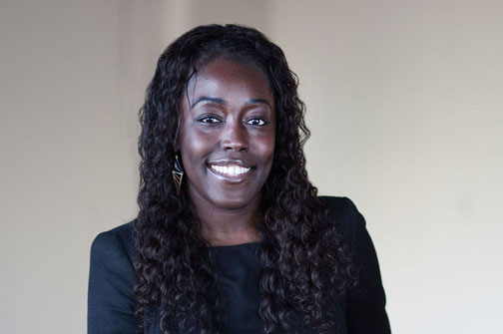

Background
My decision to undertake a career in law was sparked by watching Johnnie Chochran's advocacy in the OJ Simpson case. At around nine years old, I was too young to comprehend exactly what it was that Mr Cochran was doing. However, I recall deciding that when I grew up, I wanted "to do what Mr Cochran did". Fast forward nine or so years, I was leaving my home in Leeds to embark upon my Law Degree.

In 2008, I graduated from the University of Birmingham with a 2:1 in Law LL.B (Hons). After serious contemplation, I decided that I wanted to become a solicitor, rather than a barrister (not quite what Mr Cochran did, but close enough for me!). After completing my LPC at the College of Law in Birmingham, I began my training contract at DLA Piper, in August 2010. Much to my pleasure, three of my four seats were contentious (Insurance, Employment and Litigation), with Real Estate being my only transactional seat (which, I also enjoyed). I eventually qualified into the Litigation team in 2012.

In May 2014, I moved to Squire Patton Boggs. I work in a fast-paced litigation team dealing with the full spectrum of commercial disputes for various FTSE-100 national and international companies, and SMEs. I specialise in defamation and reputation management, and pensions disputes.

Since 2015, I have undertaken the role of Trainee Supervisor, and have also acted as a mentor for a number of colleagues over the last few years. I enjoy guiding and inspiring trainees and junior solicitors.

In March 2022, I was delighted to win the West Midlands Business Desk Diversity & Inclusion Leader of the year and overall Leader of the year awards.

Reasons why I should be elected to the Council

After living in Birmingham for over 17 years, I have placed firm roots here. My legal career commenced and continues to thrive in Birmingham; a city that I love and am passionate about.

I have been a Birmingham Law Society Council Member for the last three years and undertaken the role of Joint Honorary Secretary for the last two years. I am also a member of the BLS's REACH, EDI, Social Mobility and Dispute Resolution Committees. These roles have been thoroughly enjoyable and given me a comprehensive insight into the workings of the BLS. They have also afforded me the opportunity to work with and learn from some amazing people. I would therefore love to continue my involvement with the BLS as a Council member, drawing on the knowledge gained and my experiences from the above roles to continue to assist the BLS and its members with enthusiasm

In particular, I am keen to continue to represent the interests of junior to mid-level solicitors, and solicitors from diverse ethnic backgrounds at international or national law firms.

Having trained and worked as a solicitor in Birmingham for around twelve years, I have established a number of connections within the Birmingham legal and general professional communities, via my networking skills and activities. I also try to take part in Birmingham University Alumni events, in order to maintain my links with the University - law students in particular. I am able to leverage these connections for the benefit of the BLS. From the perspective of my own personal development, I would also like to continue to create/grow relationships with BLS Council members, and the wider membership.

More generally, I would like to do my part to help the BLS continue to achieve the aims set out in its mission statement. In particular, it is important to me to help represent the professional interests of litigators (whether that be via consultations, discussions, lobbying etc) in an ever-changing civil litigation landscape. Being elected to Council will allow me to take a more active role in representing the Birmingham legal profession in these and other areas.

Grace Mullis

I am delighted to be a family law solicitor at Irwin Mitchell LLP. I qualified in May 2021. I specialise in divorce, financial matters, and private law issues relating to children. I am passionate about helping all families; from those with complex assets to be untangled, to those with very limited assets to be shared between two households whilst adapting to co-parenting. I have a particular focus on finding resolution for my clients outside of court where possible, by supporting people through mediation and/or reaching a negotiated agreement.
Outside of the office I am a keen netball player and theatregoer. I live in Birmingham city centre and have been advocating to save Birmingham’s unfairly given reputation since attending University of Birmingham in 2014. I am passionate about supporting local initiatives and charity work across the city, in particular ‘Let’s Feed Brum’ (homeless charity) and a student mentoring programme to which increases accessibility to a career in law.

Why should I be elected
I believe that for legal professionals to deliver the best service to their clients, we must come together as a legal profession in places such as the Birmingham Law Society. I am genuinely committed to encouraging all members of the profession to feel as though they can get involved and be heard. I promise to inject my enthusiasm and experience into Birmingham Law Society, if given the opportunity as Council member.
I have thoroughly enjoyed getting involved in BLS events over the years, from pro bono initiatives to football tournaments (where I recently discovered I will not be giving up the day job…) The experience that I would like to bring to the Council comes from my past roles of Chair of the University of Birmingham Law Society to committee member of the Birmingham Trainee Solicitor Society, to now a Birmingham law society member. I am a team-player and understand the responsibility of contributing to Council meetings and idea gathering.
I work closely with young people who are hoping to enter the legal profession, and people junior in their careers (paralegals – 5 years qualified). I have lead events (both social and a support forum) to allow junior lawyers to voice their concerns and ideas for the legal profession we are re-shaping. I hope to reflect these views when contributing to BLS decisions.
I think we have a lot to learn from each other within the profession and I hope to help find new ways to bring all members together and facilitate such learning. If given the opportunity, I will listen to members and respond with creative solutions which are inclusive to all.

