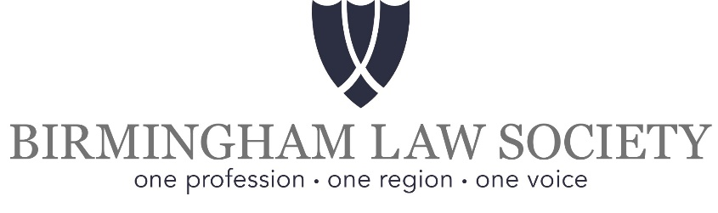

ANNUAL AWARDS TO TRAINEE SOLICITORS

Awards will be made to the winners at the Society’s Annual General Meeting which will take place at 5.00pm on Thursday 28th September 2022.

- For those currently undertaking a Training Contract
- “Gold” award: £75 of Amazon vouchers
- “Silver” award: £50 of Amazon vouchers
- “Bronze” award: £25 of Amazon vouchers

Awards will be awarded to those trainees who have attained (in descending order) the highest, second and third highest overall marks in examinations and course work in the Legal Practice Course. The Council of the Society will assess all relevant results submitted, including examination and assessment marks, and may at its discretion make further enquiries.

- For those currently undertaking a Training Contract

The David Hershman QC Memorial Award comprising Amazon vouchers to the value of £50. This award will be awarded to the student who achieved the most outstanding result of any application in the elective Family Law module of the Legal Practice Course in 2021.

- For those currently undertaking a Training Contract

The St Philips Chambers Business and Property Juniors Award Comprising a Lenovo Yoga Smart Tablet. This award will be awarded to the student who achieved the most outstanding result of any application in the Business Law and Practice module of the Legal Practice Course in 2021.

CONDITIONS:
A. Trainee solicitors must have commenced their training contracts in the calendar year of 2021 with a firm authorised to take trainees and either whose training principal is a member of Birmingham Law Society or, in a national firm where the training principal located outside Birmingham, whose training supervisor is a member of the Birmingham Law Society. This information must be included in the application.
B. Trainees must have passed their Legal Practice Course examinations at their first attempt and have obtained either a Distinction or Commendation.
C. A copy of the formal notification of the final result, together with the overall results including examination and assessment marks, must be submitted.
D. All applications must be received in WRITING as indicated below (*) by Wednesday 31st August 2022.

- For students who have completed the CPE/PgDL/GDL in 2021
The attention of Heads of CPE/GDL courses is drawn to the following awards:

(a) The Herbert Willison Award
Comprising Amazon vouchers to the value of £50. This award will be awarded to the student who achieved the most outstanding result of any application in the Criminal Law module in the Common Professional Examination (Post graduate Diploma in Law/Graduate Diploma in Law) in 2021.

(b) The Bernard Shepherd Award
Comprising Amazon vouchers to the value of £50. This award, donated by Bernard Shepherd, Past President and Chair of the Board, will be awarded to the student who achieved the most outstanding result of any application in the paper on Equity and the Law of Trusts in the Common Professional Examination (Post graduate Diploma in Law/Graduate Diploma in Law) in 2021.

CONDITIONS:
A. Students must have passed at first sitting the CPE (PgDL/GDL) in the calendar year 2021.
B. Students must have a home address in and be seeking/have obtained a Training Contract in Birmingham/West Midlands.
C. Students applying for either award must have achieved a good mark in the Criminal Law and/examination (as appropriate to their application).
D. Applications to be received in writing, as indicated below (*) by Wednesday 31st August 2022.

(*) All applicants should submit information specified above, together with FULL name (including second names), address and contact telephone number (in case of enquiries) to:

Birmingham Law Society, Suite 101, Cheltenham House, 14-16 Temple Street, Birmingham, B2 5BG

By e-mail to: janet@birminghamlawsociety.co.uk

