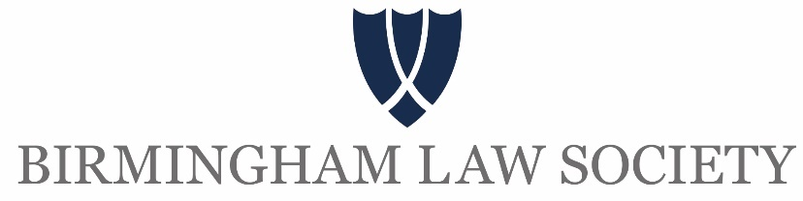

Birmingham Law Society President’s Dinner 2021

The Grand Hotel

Thursday 16 September 2021

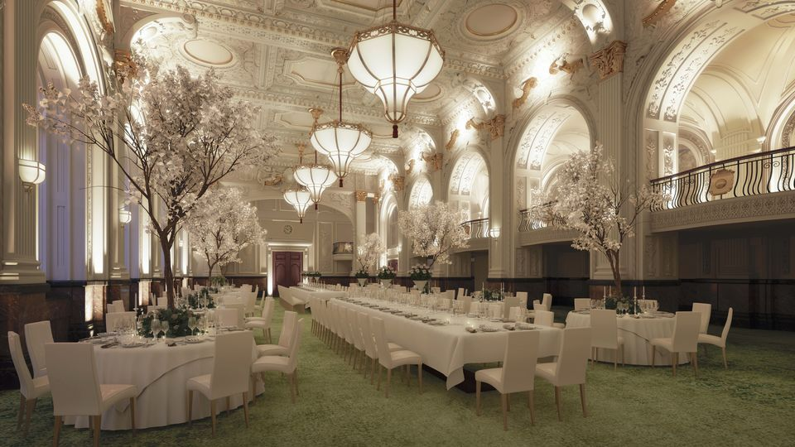

Taking place at the beautifully restored and bursting with” wow factor”, the Grand hotel Ballroom. The Grand hotel will soon re-open its doors to some of Birmingham’s most glamorous occasions with the President’s dinner being one of the first to go down in history. A venue offering a combination of period character with the latest technology.

The Birmingham Law Society Annual President’s dinner will take place on the 16 September and will attract around 250 guests. The event will have a key speaker followed by entertainment provided by a band. There will be various sponsorship opportunities available for the evening including the following benefits:

- Logo included on the programme and on the ticket for the evening
- Featured logo on the website on event page
- Marketing to include sponsor logo and a click through to sponsor website
- Display stands and banners in the venue including logo on the screens
- Pre and post event publicity in the Society's magazine Bulletin, the website and via e-mailers/e-flyers and social media
- A marketing and social media strategy will be planned to deliver our sponsors a full experience of exposure from start to finish
- Social Media coverage across 4 platforms – LinkedIn, Twitter, Facebook and Instagram
- A table of 10 at the event in a VIP location
- Promotional material displayed on table
- Photo opportunities with Media wall

Cost: £2500 plus VAT

We can tailor a package to suit your budget, please contact becky@birminghamlawsociety.co.uk for further information.

