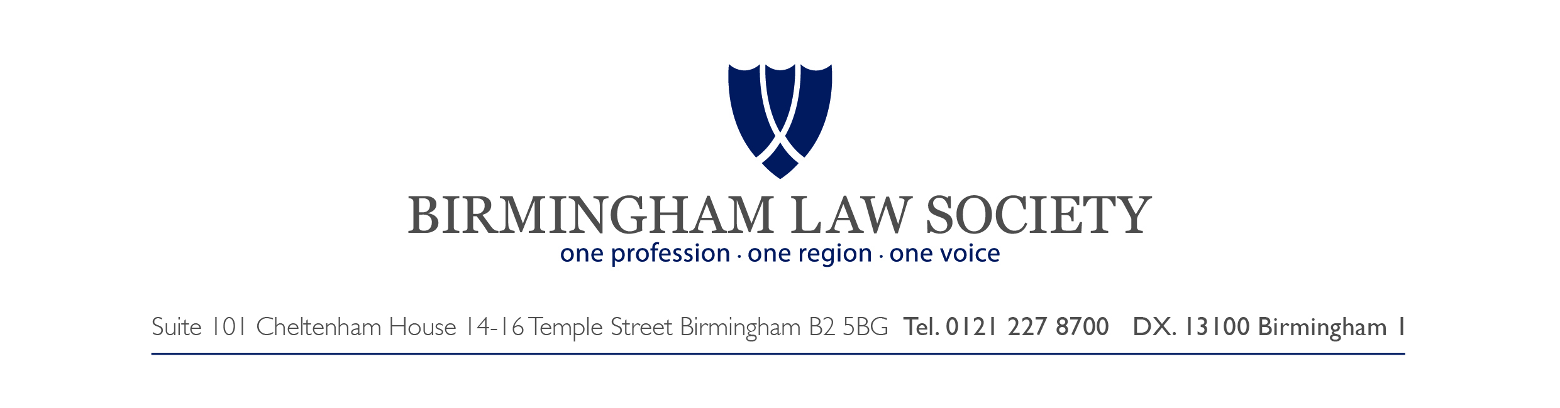**Open Consultation: National Living Wage and National Minimum Wage 2016 evidence**

**Response by the Birmingham Law Society Employment Law Committee (hereinafter ‘the Committee’)**

***Introduction***

Of the 28 questions posed as part of the Low Pay Commission Consultation 2016, many are geared towards eliciting information from those who employ minimum wage workers, or from workers themselves. Given that the Committee is made up of Solicitors and Barristers in private legal practice, it is the view of the Committee that questions 1 to 24 inclusive are outside the Committee’s scope (not least given that those questions seek input relating to the general economic outlook (questions 1 to 3), the economic impact on various interested parties (questions 4 to 9 / 21 to 24), and the setting and level of NLW and other rates (questions 10 to 20)).

The Committee felt that given the range of its experience, it might contribute in a more meaningful and relevant way on the issues relating to compliance and enforcement (questions 25 to 28) and therefore proposes to address those specific questions only.

***25. What issues are there with compliance with the minimum wage? Do particular groups experience problems with NMW (for example apprentices, those working in the social care sector, migrant workers or interns/others undertaking work experience)? What is the extent and trend?***

The Committee feel that the issues of compliance and enforcement are to a significant extent linked. The problems surrounding enforcement tend to impact on the issue of compliance. It is therefore apposite to consider enforcement first, before turning to the issue of compliance.

There are two main routes whereby NMW is enforced:

(a) by the individual worker through the statutory framework within the National Minimum Wage Act 1998, and

(b) by the HMRC as the prescribed enforcement agency.

The Committee have experience of problems with both enforcement routes.

In terms of the individual worker seeking to enforce, these problems include the following:

(i) The fact of the fees regime introduced by The Employment Tribunals and the Employment Appeal Tribunal Fees Order 2013 (under powers conferred by the Tribunals, Courts and Enforcement Act 2007). The very fact that there is a fee which is payable, will, given the frequently modest nature of NMW claims, deter workers from seeking legal redress. The now oft-quoted figure of a reduction in Tribunal claims of c.70% since the introduction of fees in July 2013 is likely to reflect the downward trend in claims to enforce NMW as it does the reduction in Working Time Directive claims, unauthorised deduction from wages claims etc.[1];

(ii) The fee remission system has not been entirely fit for purpose. The original July 2013 remission system was significantly revised by the system which came into force in October 2013 and while that ironed out some of the initial teething problems, the collation of the necessary documentation to support a remission application is by no means straightforward, and in particular the time period for submitting a remission application following the lodging of a claim is short. Moreover, most remission applications take some months to reach a determination on appeal. That places the worker in the invidious position of trying to find the fee upfront but then hoping to obtain a refund after the fact. The other alternative is withdrawing their claim which the Committee has seen occur;

(iii) The nature of the individual workers seeking to enforce NMW claims. Many such workers will be the more vulnerable individuals in the general workforce, and by the nature of their employment, possibly less sophisticated. Many will speak English as a second language, and may well have a poor grasp of English. Navigating the less than straightforward Tribunal system (including the remission system) can be a real challenge to such workers;

(iv) This problem can be compounded by the fact that a significant quantity of such workers will be casually engaged working within the regulated Gangmaster Licensing sector which traditionally has a chequered reputation in terms of ensuring NMW is paid generally[2]. Therefore the most vulnerable workers potentially face the greatest risk that they will need some recourse against failures to pay NMW.

In terms of the HMRC’s function, problems the Committee have experienced include the following:

(i) For SME’s there is a general lack of appreciation of the enforcement role that the HMRC play with regard to NMW. At the very least many SME’s do not apparently perceive the *consequences* of failing to pay NMW in the same light as, say the payment of tax, or ensuring a properly compliant health and safety infrastructure within the business, and they will prioritise accordingly. To an extent this is borne out in the BIS’ report ‘Ensuring employment comply with National Minimum Wage regulations’ (11th May 2016)[3] which not only highlights the amount of time that is taken to investigate complaints, but records that statistically, the most frequently deployed ‘weapon’ against recalcitrant employers is a ‘naming and shaming’ approach;

(ii) The actual level of HMRC enforcement is low. While the financial amount of penalties levied may at first blush appear significant (approximately £5.6 million between 2009/2010 to 2015/2016[4]) this is significantly less than £1 million per annum on average, and the number of non-compliant employers facing prosecution in the same period is less than 10[5].

In light of the matters set out above, it is the experience of the Committee that in practical terms the effective enforcement of NMW is more about voluntary compliance than it is about HMRC action/activity.

***26. What impact, if any, is the National Living Wage having on compliance and enforcement?***

Beyond the obvious matter that the fact of a higher value NLW is, in the view of the Committee, likely to lead to issues of affordability for employers and therefore increased potential failures to comply (with the knock on impact on enforcement), the Committee do not have any direct experience up to this point.

Given the limited time the NLW has been in play (since April 2016), and the time limit for bringing claims in the Employment Tribunal that lack of experience of Committee members is perhaps understandable.

The Committee would repeat the response set out in relation to question 25 above.

***27. What comments do you have regarding the enforcement work of HMRC and/or the quality and accessibility of official guidance on the NMW? What more could be done to improve compliance? Do workers and employers have enough information on the NMW and what could be done to improve it?***

The Committee’s response to this issue is foreshadowed in the response to question 25.

It is the experience of Committee members’ and their SME clients that those clients do have sufficient information on the NMW in general, but simply do not perceive the failure to pay NMW in the same light as a failure to pay, say, tax.

Nor do they perceive the consequences of a failure to pay NMW as being particularly serious. Either such a failure does not translate into workers bringing claims within the Employment Tribunal (for reasons set out above), and/or there are no particularly serious consequences at the hands of HMRC.

***28. What are your views on current arrangements for the accommodation offset? How far is it protecting low paid workers or otherwise? What difference, if any, has the increase in the value of the offset since 2013 made to the provision of accommodation?***

The Committee have had limited experience with regard to the accommodation offset. There is therefore a limit to the input the Committee is able to provide on this question.

One member has experience within the Gangmasters Licensing sector of a Gangmaster seeking to increase the amount deducted for accommodation beyond the prescribed limit, and another matter where a Gangmaster sought to charge workers for utilities outside of the accommodation offset.

In each case the Gangmasters Licensing Authority (whose Licensing Standard no.2.2 provides for a potential “critical” – i.e. licence revoking – failure where there is a failure to pay NMW[6]) dealt with the matter in a robust manner.



**President**

**Birmingham Law Society**

**29 July 2016**

1. See statistical analysis performed by the TUC and Unison for the first 3 months of 2013 and 2015.
2. http://www.gla.gov.uk/whats-new/latest-press-releases/250716-shropshire-gangmaster-revoked-for-chopping-hours/
3. https://www.nao.org.uk/wp-content/uploads/2016/05/Ensuring-employers-comply-National-Minimum-Wage-regulations.pdf
4. https://www.nao.org.uk/report/ensuring-employers-comply-with-national-minimum-wage-regulations/
5. https://www.nao.org.uk/report/ensuring-employers-comply-with-national-minimum-wage-regulations/
6. http://www.gla.gov.uk/media/1596/licensing-standards-may-2012.pdf